I

Project Title: LeaseDwelling

(By SEMESTER – VI of III Year M.Sc.(2017-18)

Student Name : Roll no.

1. Disha Pandya : 3042
2. Misha Thakkar : 3079

Name of Company/Institution: Acute Surgical Date of submission: 28-04-2018 Submitted To

K.S.School of Business Management

M.Sc.- Computer Applications and Information Technology.



**Index**

II

|  |  |  |  |  |
| --- | --- | --- | --- | --- |
| Sr.No | Name of Topic | | | Page Number |
|  | Title | | | I |
|  | Certificate | | | II |
|  | Acknowledgements | | | III |
|  | List of Figures | | |  |
|  | List of Tables | | |  |
|  | Table of Contents | | |  |
| Chapter 1 | Introduction | | | 1 |
|  | 1.1 | Organization Profile | | 1 |
|  | 1.2 | System Details | | 2 |
|  |  | 1.2.1 | Existing System | 2 |
|  |  | 1.2.2 | Proposed System | 2 |
|  | 1.3 | Scope | | 3 |
|  | 1.4 | Objectives | | 3 |
| Chapter 2 | Proposed System Requirement Gathering | | | 4 |
|  | 2.1 | Stackholder of System | | 4 |
|  | 2.2 | Requirement Gathering Technique Used | | 5 |
|  | 2.3 | Consolidated List of Requirement | | 6 |
|  | 2.4 | Project Definition | | 8 |
| Chapter 3 | System Management and Planning | | | 9 |
|  | 3.1 | Feasibility Study | | 9 |
|  |  | 3.1.1 | Technical | 9 |
|  |  | 3.1.2 | Economical | 9 |
|  |  | 3.1.3 | Operational | 10 |
|  | 3.2 | Hardware –Software Requirement | | 10 |
|  | 3.3 | System Panning | | 11 |
|  |  | 3.3.1 | Work Breakdown Structure | 12 |
|  |  | 3.3.2 | GANTT chart | 13 |
|  | 3.4 | Process model | | 14 |
| Chapter 4 | System Analysis and design | | | 15 |
|  | 4.1 | UML(Unified Modeling Language) | | 16 |
|  | 4.2 | System Flow Diagram | | 26 |
|  | 4.3 | Data Dictionary | | 19 |
|  | 4.4 | User Interface | | 36 |
|  | 4.5 | System Navigation | | 40 |
| Chapter 5 |  | Input Output Design | | 41 |
| Chapter 6 |  | System Testing | | 61 |
| Chapter 7 | 7.1  7.2  7.3 | Summary Assumptions Limitation Future Scope  Bibliography | | 67 |

**List of figures**

III

|  |  |  |
| --- | --- | --- |
| Sr.no | Figures | Page Number |
| 1 | 3.3.1 Work Breakdown Structure | 12 |
| 2 | 3.3.2 Gantt Chart | 13 |
| 3 | 3.4 Incremental model | 14 |
| 4 | 4.1.1 Use case - Buyer | 16 |
| 5 | 4.1.2 Use case - Seller | 17 |
| 6 | 4.1.3 Use case - Admin | 18 |
| 7 | 4.1.4 Activity Diagram – Buyer | 20 |
| 8 | 4.1.5 Activity Diagram – Seller | 21 |
| 9 | 4.1.6 Activity Diagram – Admin | 22 |
| 10 | 4.1.7 Sequence Diagram – Buyer | 24 |
| 11 | 4.1.8 Sequence Diagram – Seller | 25 |
| 12 | 4.2.9 Sequence Diagram – Admin | 26 |
| 13 | 4.3.7 Class diagram | 35 |
| 14 | 4.2 System Flow Diagram –Buyer | 28 |
| 15 | 4.2 System Flow Diagram-Seller | 28 |
| 16 | 4.2 System Flow Diagram –Admin | 28 |
| 17 | 4.4.1 User Interface – Home page | 37 |
| 18 | 4.4.2 User Interface – Registration Page | 38 |
| 19 | 4.4.3 User Interface – Log In Page | 39 |
| 21 | * 1. System Navigation   2. Front End Design   3. Report Design | 40 |

**List of tables**

|  |  |  |
| --- | --- | --- |
| Sr.No | Tables | Page Number |
| 1 | 4.3.1 Buyer_master | 30 |
| 2 | 4.3.2 Admin_master | 30 |
| 3 | 4.3.3 Seller_master | 31 |
| 4 | 4.3.4 Property_master | 31 |
| 5 | 4.3.5 Booking_master | 32 |
| 6 | 4.3.6 feedback_master | 33 |

**CHAPTER 1 : INTRODUCTION**

1

* 1. **ORGANIZATION PROFILE**

India is a global leader in the manufacturing of surgical instruments. Acute Surgical is based in India and its team is recognized as being a pioneer in manufacturing ophthalmic bladed/knives of international quality standards. We put quality first with strict quality control measures in place at all stages of our manufacturing process.

Acute Surgical corporate office and manufacturing unit are located in city of Ahmedabad of Gujarat state in India. The manufacturing unit is situated over 8000 sq ft on the outskirts of the city. The environment in which the manufacturing facility is located is a very clean and pristine locale. This provided us with an optimum location for an extremely well controlled manufacturing unit, an advantage most of competitors don’t have.

Acute Surgical is managed by a team of highly qualified professionals, all of whom have a great deal of experience in the field of surgical instruments manufacturing. The technical and educational expertise the team shares makes for an unmatched level of professionalism.

Our team understands the needs for constant improvement and ISO & CE Mark level products. We strive for the best quality in both manufacturing and services. Not only do we constantly focus on developing new products, we spend a great deal of time and effort on improving existing ones. We have been trained in Six Sigma and ISO procedures and understand the need for perfection.

Products and Capability :

* + - Manufacturer of Ophthalmic Micro Surgical Blades, Knives and Miniature Blades with all in House processes with ISO 9001 – 2008 and level to CE Mark manufacturing.
    - Supplier of standard surgical products, surgical instruments and devices of national and

international companies.

* + - Capable of doing R&D and manufacturing of customized surgical cutting quality instruments.

|  |  |
| --- | --- |
| Company name | Acute Surgical |
| Address | Mondeal Heights, A-1112, 11th floor, nr. Novotel hotel, S.G. Road, Ahmedabad-  380015 , Gujarat, India |
| Contact no. | 07929709006, 9825009008 |
| Email Id: | [contact@acutesurgicalcorp.com](mailto:contact@acutesurgicalcorp.com) ,  [info@acutesurgicalcorp.com](mailto:info@acutesurgicalcorp.com) |

* 1. **SYSTEM DETAILS**

2

* + 1. **Existing System**
       - Moving from one place to another place for long/short time period is stressful either from one to another house or else with the current properties as well as required things, as price of rent are floating as per season now days it is tougher and more complicate than before.
       - The current web applications provides information about rent, choices (for male, female or couple).
       - In current system user don’t give priority to web application because it occupied more rent, also take high brokerage from clients and also take some advance that is why it is hard to manage for middle class person.
       - Some of the current systems are not able to provide punctual and appropriate services, features, facilities as well as comfort which user expect because of some backlogs like late response, don’t provide appropriate platform for proper communication between users and rentals.
       - Mostly user want to purchase house in their own requirements and choices like location, nearby places (food-market , hospital , mall , garden etc) , neighbours , population of that area , some facilities (parking , watchman , daily newspaper as well as milk supplies ) etc , but some current systems are not providing such filter and choice to their users.
       - Users get problems after dealing with rentals or purchasing new house because of less information which should they know before having deal and through better communication also users and rentals can discuss their rate as well as some additional requirements / conditions if required.
    2. **Proposed System**

To overcome above drawbacks of current systems we give better platform to user and rentals to do appropriate deals as well as users get better options to house on rent or purchase their own.

* + - * Now days people are being more smarter to invest their money in appropriate property by gathering all information and keep their requirements in mind.
      * Here we provide platform to both- users and rentals/owners. Both can creat their id here securely. Users get maximum filters and options for their choice and requirements. Rentals/Owners can also create their account and get facilities to upload all the information about the property , features , facilities , fare , price as well as images or videos also ofwhich they want to give on rent or sell.
      * After registration users and rentals get facilities to communicate also where both can put their conditions, decide rate of fare, price if user going to purchase house, users can get replies of every query by asking to the owner of which one they are interested.
      * Users can also enter their requirements that’s why better options and houses can be suggested by our
      * system. Both (users , rentals) can get notifications in their registered email of daily updates of new properties , houses on rent or to purchase , suggestions , offers and availability.

3

* 1. **SCOPE OF SYSTEM**

Day by day the requirements of every person are increasing mainly considering better facilities as well as modern life style. Both side of people can access this website either at a customer side or at owner side.

Main purpose of this system is to make everyone facilitate, so users can get information relevant their requirements and demands like Wi-Fi zone, Swimming pool, laundry, Educational Activity , Gym and all modern life style , location etc same at other side owner also get platform to upload their properties.

This web application is also make comfort for those who want to furnish their house as a paying guest facility or make available on rent will need to log in and submit all the details about their house, rent and other related amenities.

* 1. **OBJECTIVES**

The main objective of this project is to build Rent house and paying guest that enable the time management and making easy system that people can easily find out the information which they want. And from any place they can find out their best deals.

**Advantages:**

* It helps to reduce the work load of agents.
* It simplifies billing procedure.
* It easy to handle new changes done in the system.
* It helps to save time and money.
* Quick and easy internal & external communication system.
* Customer can understand rent details according to packages.
* Paying guest can give feedback.
* Paying guest can possible to get rent receipt, rent status and other updates on their login panel
* One click shows you vacancy room list and occupancy chart
* Add, Edit, Update Paying guest details easily. Possible to view Date Rent Report online.

# CHAPTER 2 PROPOSED SYSTEM REQUIREMENT GATHERING

4

* 1. **STACKHOLDER OF SYSTEM**

In this web Application There are mainly four stack holder, which are divided in following:

## Administration:

* + - * Admin is owner of web application, who manage the all aspect of the system.
      * Admin have to give updates about the requirements of clients to landlords, and landlords to clients.
      * Administration will take 2% of brokerage after all the transactions of landlords and clients to our web application.

## Landlords:

* + - * Landlords who is the owner of house , means they will be sell their house, house on rent or paying guest. They can contact with admin.
      * They have to put their services, price and some other facilities which they provide to clients.
      * They have to add their profile which includes name, address, contact number, email-id , details of house and they can also check their visitors and clients requirements.
      * They can check their client’s requirements via feedbacks and complain box and try to fulfil their requirements.

## Clients:

* + - * Clients can find house, house on rent or paying guest as per their requirements.
      * Clients can add more requirements and give their feedback about services.
      * If client wants to change payment facilities they can contact to administrator.

## Visitors:

* + - * Visitors can add more requirements and give their feedback about services.
      * Visitors can overview the web application.
      * If they are interested in this application they can register in to the web application.
  1. **REQUIREMENT GATHERING TECHNIQUE USED**

5

It is critical to capture the necessary facts to build the required database application. These facts are

captured using fact-finding techniques. The formal process of using techniques such as interviews and questionnaires to collect facts about systems, requirements, and preferences.

A database developer normally uses several fact-finding techniques during a single database project including:

* Examining documentation
* Interviewing
* Observing the organization in operation
* Research
* Questionnaires

In Requirement gathering we use Different type of Fact-Finding Techniques like interview observation etc.

With using of Fact-Finding Technique we get Following Questions and Answers:

* 1. Why do you want to create this type of the web application?

Ans-1 because in current system some way internal process problems occur and which is not so useful for users. Technical way current system is slow in work and for that reason transaction and communications delayed so users are not satisfied with it.

* 1. what was problem in current system?

Ans-2 such transaction record stored on paper which is not easy to maintain and also communication problems arises. Current system occupied more rent from clients they take advance rent, main rent and also take high brokerage for which clients are not satisfied. current system is not provide facilities to clients as per their requirements. Current system is also time consuming which is not good technical way.

* 1. what is the functionality you want in your proposed system?

Ans-3 the proposed system must be computerized in which user can access the system from anywhere. Proposed system will fast in work so users don’t need to wait for use this web application. Who want to sell their house, house on rent and paying guest they can create their profile and add details. Client’s requirements will fulfil as early as possible and also they can add more requirements via feedbacks or mail. Current system occupied more rent from clients but to overcome this disadvantage proposed system will focus on clients comfort and will take minimum brokerage.

* 1. why will you attract landlords to join your web application?

6

Ans-4 people who want to sell their house, give house on rent or paying guest for them this web application will very useful. Because sometimes they have to find buyers, put posters on walls to

advertise for sell, but with the help of this web application they will easily put details about their house and services and also add their profile so users can see it and attract to buy house.

* 1. how will web application attract to visitors?

Ans-5 this web application adds very interesting things, add more attractive facilities and also give visitors to select their own choice of house. And they also add their requirements and get immediate feedbacks.

* 1. how will administrator make more useful this web application?

Administrator will handle this web application for a communication with users, clients and landlords also manage both account and give them updates. Online transaction via debit/credit card, paytm or any other online transactions. Administrator provide fast services and reply to users, clients and landlords and also give solutions of their problem.

* 1. **CONSOLIDATED LIST OF REQUIRMENT**

Task for administrator:

* Check for new registration
* Manage both owner
* Manage client profile
* Manage feedback
* Give updates
* View chart of owners
* View chart of clients
* Profit
* Current and past comparison
* Web application content
* Web app will get 2% of brokerage from every successful transaction.

Task for Seller:

7

* Registration
* Sign in
* Create their own profile
* Detailing about paying guest, rent house and sell house.
* They have to fixed selling amount
* To add description
* Add Location , area as per requirements
* Services(Wi-Fi, tiffin, laundry, etc.)
* Add photos/videos regarding house
* They will Collect reviews of client
* They fix Visiting hours for client meeting

Task for Buyers:

* Client can create their own profile
* they book their house, paying guest or rent house
* they have to add personal details after login
* if they forgot their profile password they can go to forgot password link and reset their password.
* They visiting personally
* They can view photos and videos
* Add feedbacks
* They can add complains or their more requirements
* Select paying method(cash, online transaction, etc.).
* Received updated notifications.
* Book appointment for meeting with Seller.
  1. **PROJECT DEFINITION**

8

Lease Dwelling is java based web application. This online house, rent house and paying guest web application will provide a better solution for people who want a new house, on rent or paying guest, also who want to sell their house can add their profile and details about house.

In today's life everyone needs a house, but sometimes it is hard to find a house in big cities so our web application is trying to make comfort for those who are finding a house on rent. In our web application landlord can register themselves and they can add extra services and facilities of their lands so user can view and compare it.

Visitor can view all the details of places but for booking their places they have to register them self. After registration they will be our clients. Now they can create their profile to enter their requirements. Visitor will enter their email so they can get notifications for new and existing places.

Client can get all the information regarding house, paying guest and rent house. Also client can buy house from this web application. Clients can view photos and videos of place which owner have added.

Admin can manage web content from his/her end. Also he/she can manage clients, landlord, and feedback. Even he/she can view profit, chart, register clients and owners also he/she can compare all details with past.

# CHAPTER 3: SYSTEM MANAGEMENT AND PLANNING

9

* 1. **FEASIBLITY STUDY**

Whatever we think need not be feasible .It is wise to think about the feasibility of any problem we undertake. Feasibility is the study of impact, which happens in the organization by the development of a system. The impact can be either positive or negative. When the positives nominate the negatives, then the system is considered feasible.

The main objective of the feasibility study is to test the Technical, Operational and Economical feasibility for adding new modules and debugging old running system. There are aspects in the feasibility study portion of the preliminary investigation:

 Technical Feasibility  Operation Feasibility  Economic Feasibility

**3.1.1 Technical Feasibility:-**

* + - The technical feasibility study focuses on how you will deliver a product or service how you will deliver a product or service through which technology?
    - The current system developed is technically feasible.
    - It is a web based user interface. Thus it provides an easy access to the users.
    - To access the system, internet connectivity is must require, because it is web Based websites.

# 3.1.2 Economical Feasibility:-

* + - Economic feasibility is based on cost and be benefits.
    - The cost of hardware and software for the class of application being considered.
    - The benefits in the form of reduced costs of fewer costly errors.
    - The cost if nothing change (i.e. the proposed system is not developed).
    - We are using the open source platform to build our system.
    - Thus, the project is economically feasible for both client and us.

**3.2.3 Operational feasibility:-**

10

* + - Operational feasibility states how the requirements are satisfied and also provides possible solutions.
    - By doing so there is no need for the company either to recruit some special individual to run the system or spend a huge amount to train some individual.
    - Thus, the project is operationally individual.
    - This project well-planned design would ensure the optimal utilization of the resources and would help in the improvement of performance status.

**3.2 HARDWARE-SOFTWARE REQUIRMENT**

* + 1. **Hardware (Recommended)**
       - Processor: Minimum Pentium
       - Hard Disk: 80 GB
       - RAM: 512 MB or More
       - An Internet Connection
    2. **Software (Recommended)**
       - Windows XP,7,8,8.1,10 or any higher versions of OS
       - My SQL
       - Any Web Browser
    3. **Technology Used**

Frontend Technology:

* JSP-Servlet:
* HTML:
* CSS:
* JQUERY:

Frontend Tools:

* Photoshop CS6
* Eclipse

Backend Technology:

* JAVA

11

Backend Framework:

* + JDBC
  + Spring
  + Hibernate
  1. **SYSTEM PLANNING**
     1. **WORK BREAKDOWN STRUCTURE**

### What is a work breakdown structure?

Simply put, a work breakdown structure is a hierarchical decomposition of the scope/work that needs to be estimated and executed during the course of the project in order to accomplish the project objectives and deliverables.

**WORK BREAKDOWN STRUCTURE**

12



1 Lease Dwelling

1.1.1 Stack Holder of System

1.3.1 UML Diagrams

1.4.1 Code Construction and Review

1.6.1 Service

* + 1. Requirement Gathering Techniques
    2. Finalize Requirement List

1.3.2 System Flow Charts

1.6.2 Facility

1.3.3 Data Dictionary

1.6.3 Feedback

1.1.4 Project Definition 1.3.4 User Interface

1.3.5 System Navigation

1.2 Project Management & Planning

1.2.1 Feasibility Study

1.5.1 Development Testing

* + 1. H/w S/w Requirement 1.5.2 Operational Testing
    2. Project Management and planning
    3. Process Model

1.5 Testing

1.6 Maintains & Support

1.4 Coding

1.3 Analysis & Design

1.1 Requirement Gathering

* + 1. **GANTT CHART**

The first Gantt chart was devised in the mid 1890s by Karol Adamiecki, a Polish engineer who ran a steelworks in southern Poland and had become interested in management ideas and techniques. Some 15 years after Adamiecki , Henry Gantt, an American engineer and project management consultant, devised his own version of the chart and it was this that became widely known and popular in western countries.

Consequently, it was Henry Gantt whose name was to become associated with charts of this type.

**What is a Gantt Chart?**

A Gantt chart, commonly used in project management, is one of the most popular and useful ways of showing activities (tasks or events) displayed against time. On the left of the chart is a list of the activities and along the top is a suitable time scale. Each activity is represented by a bar; the position and length of the bar reflects the start date, duration and end date of the activity. This allows you to see at a glance:

* + - * What the various activities are
      * When each activity begins and ends
      * How long each activity is scheduled to last
      * Where activities overlap with other activities, and by how much
      * The start and end date of the whole project

13

*Aug 2017 Sep 2017 Oct 2017 Nov 2017 Dec 2017 Jan 2018 Feb 2018*

*ID Task Name Start Finish Duration*

1 Requirement

gathering

10-07-2017 25-08-2017 7w

Project

2 management and plannig

25-08-2017 22-09-2017

4.2w

3 Analysis and

design

22-09-2017 29-12-2017 14.2w

4 Coding

29-12-2017 22-02-2018 8w

5 Testing and

maintance

22-02-2018 15-03-2018 3.2w

* 1. **PROCESS MODEL**
* The process model is a core diagram in structured analysis and design. Each process Transforms inputs into outputs.
* In order to complete our project in total of ten months duration, what we should do exactly is following the analysis, design, and implementation and testing parts one by one and in each one of these parts returning the previous ones and do some modifications where necessary. What we need is definitely the characteristics of the incremental model.

**Incremental Model**

* The incremental model combines elements of the linear sequential model (applied Repetitively), with the iterative philosophy of prototyping. Incremental Model is combination of one or more Waterfall Models. In Incremental Model, Project requirements are divided into multiple modules and each module is developed separately. Finally developed modules are integrated with other modules. During development of each module, waterfall model is followed for each module development separately and passes through the requirements, design, implementation and testing phases.
* The series of releases is referred to as “increments”, with each increment providing more Functionality to the customers. After the first increment, a core product is delivered, which can already be used by the customer. Based on customer feedback, a plan is developed for the next increments, and modifications are made accordingly and this process continues until product is delivered.
* Early increments can be implemented with fewer people. If core product is well received, then additional staff can be added to implement the next increment.
* We increments earlier to the main increment are called as “stripped down” versions of the final product.

14

* If there are less number of employees to work on the project Incremental development model is very useful to complete the project before the deadline. In a project early increments can be done with less number of people. In case if the core product is well-defined and understood more employees can be added if needed in the future increments.
* One of the benefits of Incremental process model is that it can be planned to manage technical risks.
* Diagram of Incremental Process Model:

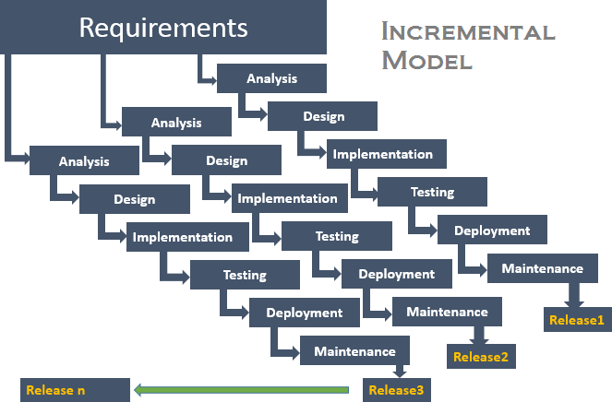

Steps:

These tasks are common to all the models

Planning: required as many people (software teams) work on the same project but different function at same time.

1. Modeling: involves Analysis and Design.
2. Construction: this involves the implementation (coding) & testing.
3. Deployment: integration of all the increments.

# CHAPTER – 4 – SYSTEM ANALYSIS and DESIGN

15

* 1. **UML Diagram**

The Unified Modelling Language is standard visual modelling language intended to be used for :

* + - Modelling business and similar processes,
    - Analysis, design and implementation of software-based systems

UML can be applied to diverse application domains(e.g. banking, finance, internet, aerospace, healthcare, etc.) It can be used with all major object and component software development methods and for various implementation.

* + 1. **Use case Diagram**
* To model a system, the most important aspect is to capture the dynamic behaviour. Dynamic behaviour means the behaviour of the system when it is running/operating.
* Only static behaviour is not sufficient to model a system rather dynamic behaviour is more important than static behaviour. In UML, there are five diagrams available to model the dynamic nature and use case diagram is one of them.
* Now as we have to discuss that the use case diagram is dynamic in nature, there should be some internal or external factors for making the interaction.
* These internal and external agents are known as actors. Use case diagrams consists of actors, use cases and their relationships. The diagram is used to model the system/subsystem of an application. A single use case diagram captures a particular functionality of a system.
* Hence to model the entire system, a number of use case diagrams are used.
* In brief, the purposes of use case diagrams can be said to be as follows :
* Used to gather the requirements of a system.
* Used to get an outside view of a system.
* Identify the external and internal factors influencing the system.
* Show the interaction among the requirements are actors.

16

Registration

LogIn

View Profile

ManageProfile

Location Area(In Square Feet)

Facilities

Search Property Details

Price

Registered project

Apartments

View Properties

Independent house

flat

Under construction

List their requirements and conditions

Add

Remove

Ask Queries

Buyer

Purchase

Pre-Booking

Rent



Cancel

Do payment

View Feedback

Give feedback & Ratings

LogOut

17

Registration

LogIn

View Profile

ManageProfile

Location Area(In Square Feet)

Facilities

Price

Post Property Details

Registered project Apartments

Post properties

Independent house

flat

Under construction

Manage Own Properties

Add

Remove

Seller

Check Booking

Purchase

Rent



Reply Queries

Receive Payment

VIew Feedback &Ratings

Give feedback & Ratings

LogOut

18

LogIn



ManageOwnProfile View Buyer

ViewUsers

View Seller

View Requirement

Location Area(In Square Feet)

Facilities

Price

View Property Details

Registered project

Apartments

View Properties Independent house

flat

Check Booking

Purchase

Rent

Under construction

Admin

View Feedback &Ratings

LogOut

* + 1. **Activity Diagram**

19

* Activity diagrams are graphical representations of workflows of stepwise activities and actions with support for choice, iteration and concurrency. In the Unified Modelling Language, activity diagrams are intended to model both computational and organizational processes
* Activity diagram is another important diagram in UML to describe the dynamic aspects of the system.
* Activity diagram is basically a flowchart to represent the flow from one activity to another activity. The activity can be described as an operation of the system.
* The control flow is drawn from one operation to another. This flow can be sequential, branched, or concurrent. Activity diagrams deal with all type of flow control by using different elements such as fork, join, etc.
* The purpose of an activity diagram can be described as −
* Draw the activity flow of a system.
* Describe the sequence from one activity to another.
* Describe the parallel, branched and concurrent flow of the system.

20

* + 1. Buyer Activity

Start Home page



Account not



Registration

~~Exist~~

Account exist

Not successfully



Login

success fully

View own profile

Enter Requirement

View property

Make Payment

Ask Queries to Seller

Feedback

Manage Profile

Upadate Requirments

Online

offline

Details

Property

Update Profile

Booking

View Feedback &Ratings

Give Feedback &Ratings

Registr ed Project

Locati Area(In Faciliti

Purchase

Rent

on

Square Fit)

es

Price

Apartm ent

Under Constru ction

Flat

Indepen dent House

Logout

21

* + 1. Seller Activity

Start Home page



Account not

~~Exist~~ Registration

Not successfully

Account exist

Login

success fully

View own profile

Manage own Profile

Update profile

View Buyer

View Requirmnets and Conditions

View Booking

Manage Proprties

Details Properti

es

Receive payment

Online Offline

Reply Queries of Buyer

Feedback

View Feedback and Ratings

Give Feedback ans Ratings

Purchase

Rent

Locati

on Area(In Square

Fit)

Faciliti es

Price

Registr ed Project

Apartm ent

Indepen dent House

Under Constru ction

Flat

Logout

22

* + 1. Admin Activity



Start

Not successfully

login

Vali d?

Successf ully

View Buyer

View Seller

View own Profile

View Feedback

Manage Own account

View Profile

Check their requirments and condition

View Profile

Check Property

Check Booking

Check their informati on about property

Registr ed Project

Apartm ent

Under Constru ction

Flat

Insert Update Delete Details Details Details

Locati on

Area(In Square Fit)

Faciliti es

Price

Indepen dent House

Purchas e

Rent

Logout

* + 1. **Sequence Diagram:**

23

A sequence diagram is an interaction diagram that shows how objects operate with one another and in what order. It is a construct of a message sequence chart.

A sequence diagram shows object interactions arranged in time sequence. It depicts the objects and classes involved in the scenario and the sequence of messages exchanged between the objects needed to carry out the functionality of the scenario. Sequence diagrams are typically associated with use case realizations in the Logical View of the system under development. Sequence diagrams are sometimes called event diagrams or event scenarios.

A sequence diagram shows, as parallel vertical lines (lifelines), different processes or objects that live simultaneously, and, as horizontal arrows, the messages exchanged between them, in the order in which they occur. This allows the specification of simple runtime scenarios in a graphical manner.

24

4.1.7 Buyer Sequence



**Buyer Register LogIn**

**Search category for property**

**Search for requirem ents**

**Book Property**

**Manage**

**Payment profile**

**Feedbac k**

**LogOut**

**Database**

Register information Register aknowlegment

Username & password Redirect to home category Category

Category details

arch location, industrial or commercial, design,price,rent,Facility View all result

Add their requirements after viewing categories Sucessfully add requirements and check it out

want to purchase or want on rent Booking sucessful

Cancel Property Receive cancellation message

pay money online Transaction sucessful Pay offline

Receive confirmation

Update details Updation sucessful

Add feedback Add sucessfully

Request logout Sucessfully LogOut

25



**Seller**

**Register**

**LogIn**

**Add category for property**

**Search for Buyers requirem ent**

**View Book Property**

**Take Payment**

**Manage profile**

**Feedbac k**

**LogOut**

**Database**

Register information

Register aknowlegment

Username & password

Redirect to home category

cation, industrial or commercial, design,price,Facility,for rent or sell

Add sucessfully

Search buyers requirements after adding categories view results of buyers

View bookings

Give confirmation to buyer

Receive money online Transaction sucessful Receive offline Generate receipt

Update details Updation sucessful

Request to view feedback View all buyer feedback

Request logout Sucessfully LogOut

26

4.1.9 Admin Sequence



**Admin**

**LogIn**

**Manage**

**Buyer**

**Manage**

**seller**

**Manage**

**Property**

**Manage**

**Profile**

**Database**

Request to Login

Redrect to homepage

Add/update/delete info and view all process

Add/update/delete and manage buyer successful

Add/update/delete info and view process

Add/update/delete and manage seller successful

Request for view property details and add/update/delete property info if necessary Manage property sucessfully

Update/Delete Details

Manage sucessgully

* 1. **Systemflow Diagram**

27

**System Flow Diagram** is basically a graphical and sequential representation of the major steps involved in a systematic process.

A **SFD(System Flow Diagram)** shows what kind of information will be input to and output from the system, where the data will come from and go to, and where the data will be stored

* 1. System Flow Diagram



Start

LogIn

User Nam e Pass word

Registra tion

Forgot Password

Enter email Id

Enter Data

Valid

Submit

No

Valid

Vali d

Process

Registra tion Sucessf ul

Buyer

Seller

Admin

A

B

C

28



A

Search Properties

Loaction and Details

**Book House**

Payment

Update Profile

LogOut

Price

Search category

Area(In square

Online

Cancel Booking

Commer

Apartme

Underfeet) construc

tor or readyma de

After commun icating with seller

Online

Offline

nts Indepeinndustria

cial or

dent house

l

End



B

Add Property Details

View Buyers

nder construc tion or

Manage Buyers

Take Payment

Update Profile

LogOut

To sell

To Rent

Commer cial or

heck buyer

Check

Online

Location

Commer

readyma

want to Givewant on

buyer

industria

cial odre industria

purchaasnswerrent

l

Location

l

e to buyer of

End



C

Manage Buyer

Manage Seller

Manage Properties

Change Password Procedure

LogOut

Block/ Unblock

Block/ Unblock

Update/ Delete

End

* 1. **Data Dictionary**

29

**“**A **Data Dictionary** is a catalogue of elements in the system.**”** These elements centre on the data

and they structured to meet user requirements and organization needs, the major elements are data flows, data stores and processes. The Data dictionary stores the details and description of these elements.

### Why Data Dictionary is important?

* To manage the details in large systems.
* To communicate a common meaning for all system elements.
* To documents the failure of the system.
* To facilitate analysis of the details in order to evaluate characteristics and determine where the system changes should be made.
* To locate errors and omission in system.

### What does Data Dictionary record?

The Data Dictionary contains two types of description for all data following through system

### Data Elements

* + Data Description
  + Aliases
  + Length
  + Data values

### Data Structure

* + Sequence Relationship
  + Selection Relationship

### Table Name: User_master

30

**Description:** Used to store all users login and type Information.

### ‘

|  |  |  |  |  |  |
| --- | --- | --- | --- | --- | --- |
| **Sr.no** | **Column name** | **Data types** | **Size** | **Constraints** | **Description** |
| 1 | User_Id | Varchar | 10 | Primary key | It represents the user id. |
| 2 | User_Name | Varchar | 15 | Not Null | It represents the user’s  password |
| 3 | Gender | Varchar | 10 | Not Null | It represents gender of  user |
| 3 | Email_id | Varchar | 20 | Not Null | It represents the user’s  name. |
| 4. | Password | Varchar | 20 | Not Null | It represent the user’s  email id. |
| 4 | Address | Varchar | 100 | Not Null | It represents the current  address. |
| 5 | Category(Buye  r/Seller) | Varchar | 20 | Not Null | It represents the Category  of User. |
| 6 | Photo_id | Object | - | - | It represents the photo id  of user |

* + 1. **Table Name: Admin_Master**

**Description:** Used to store all Admin Information.

|  |  |  |  |  |  |
| --- | --- | --- | --- | --- | --- |
| **Sr.no** | **Column Name** | **Data Type** | **Size** | **Constraints** | **Description** |
| 1 | Admin_id | Varchar | 05 | Primary Key | It represents  the id of admin. |
| 2 | Admin_name | Varchar | 20 | Not Null | It represents the name of  admin. |
| 3 | Admin_Password | Varchar | 15 | Not Null | It represents the Password  of admin. |

### Table Name : Property_Master

32

**Description:** Used to store all Information about properties.

|  |  |  |  |  |  |
| --- | --- | --- | --- | --- | --- |
| **Sr.no** | **Column name** | **Data type** | **Size** | **Constraints** | **Description** |
| 1 | Property_id | Varchar | 05 | Primary key | It represents the id of  property. |
| 2 | Seller_id | Varchar | 05 | Foreign key | It represents the id of  seller. |
| 3 | Property_name | Varchar | 20 | Not null | It represents the name of  property. |
| 3 | Property_date | Date | - | Not null | It represents the date of  property. |
| 4 | Property_address | Varchar | 100 | Not null | It represents the added  property. |
| 5 | Property_Category | Varchar | 15 | Noy Null | It represents  the category. |
| 6 | Property_Price | Varchar | 10 | Not null | It represents  the price of property. |
| 7 | Property_Photos | Object | - | Not null | It represents the photos of  property. |
| 8 | Property_area | Varchar | 100 | Not null | It represents  the area of property |
| 9 | Property_type | Varchar | 20 | Not null | It represent  the type of property |
| 10 | Property_status | Varchar | 20 | Not null | It represent  the type of property. |

### Table name : booking _master

33

**Description:** Used to store Booking Information.

|  |  |  |  |  |  |
| --- | --- | --- | --- | --- | --- |
| **Sr.no** | **Coloum name** | **Data types** | **Size** | **Constraints** | **Description** |
| 1. | Booking_id | Varchar | 05 | Primary key | It represents  the id of booking. |
| 2 | Buyer_id | Varchar | 05 | Foreign key | It represents  the id of user. |
| 4 | Property_id | Varchar | 05 | Foreign key | It represents id of  property. |
| 5 | Booking_date | Date | - | Not null | It represents date of booking  property. |
| 6 | Property_price | Integer | 10 | Foreign key | It represents payment is received or  not. |

* + 1. **Table name : Feedback_master Description:** Used to store feedback.

|  |  |  |  |  |  |
| --- | --- | --- | --- | --- | --- |
| **Sr.no** | **Column name** | **Data type** | **Size** | **Constraints** | **Description** |
| 1 | Feedback_id | Varchar | 05 | Primary key | It represents the id of  feedback. |
| 2 | Buyer_id | Varchar | 05 | Foreign key | It represents  the id of user. |
| 3 | Seller_id | Varchar | 05 | Foreign key | It represents the id of  landlord. |
| 4 | Date | Date | - | Not null | It represents  the date . |
| 5 | Remarks | Varchar | 30 | Not null | It represents  the remarks. |

* + 1. **Class Diagram**

34

* + - * Class diagram is a static diagram. It represents the static view of an application. Class diagram is not only used for visualizing, describing, and documenting different aspects of a system but also for constructing executable code of the software application.
      * Class diagram describes the attributes and operations of a class and also the constraints imposed on the system. The class diagrams are widely used in the modelling of object oriented systems because they are the only UML diagrams, which can be mapped directly with object-oriented languages.
      * Class diagram shows a collection of classes, interfaces, associations, collaborations, and constraints. It is also known as a structural diagram.
      * The purpose of the class diagram can be summarized as −
* Analysis and design of the static view of an application.
* Describe responsibilities of a system.
* Base for component and deployment diagrams.
* Forward and reverse engineering.

35

4.3.1 Class Diagram

User_Master



User_id:varchar Password:varchar User_name:varchar

getUseractivity()

Admin_Master

Admin_id:Varchar Password:varchar Admin_name:varchar

getAdmindetails() Check info() Manage buyer() Manage Landlord()

Feedback_Master

Feedback_id:varchar Buyer_id:varchar Seller_id:varchar Date:date Remarks:varchar

getFeedbackDetails() Addfeedbackdetails() UpdateFeedbackDetails() DeleteFeedbackDetails()

Buyer_Master Buyer_id : Int

Buyer_Password: varchar Buyer_Name:varchar Buyer_Email:varchar Buyer_Address:Varchar Buyer_Photo_id:

getBuyerDetails() ViewProperty() MakeBooking() Update Info() DeleteDetails() MakePayment() AddFeedback()

Booking_Status Booking_id:varchar

Buyer_id:varchar

Property_id:varchar Booking_Date:date Property_price:int Cancel_booking:varchar

getBookingDetails() ViewAllBooking() DEleteBooking() Cancelbooking() Feedback()

Seller_Master Seller_id : Int

Seller Password: varchar Seller_Name:varchar Seller_Email:varchar Seller_Address:Varchar Seller_Photo_id:

getSellerDetails() AddProperty() ViewBooking() Update Info() DeleteDetails() ConfirmBooking() TakePayment()

PVroiepweFrtey_edMbaasctke(r)

-memberName

Property_id:varchar Seller_id:varchar property_name:varchar property_address:varchar Property_Date:date Category:varchar Property_area:varchar Property_type:varchar Property_status:varchar Price:int

Photo getPropertyDetails() viewProperty()

BookProperty()

Update property() DEleteProperty()

36

* 1. **User Interface**

User interface is the front-end application view to which user interacts in order to use the software. User can manipulate and control the software as well as hardware by means of user interface. Today, user interface is found at almost every place where digital technology exists, right from computers, mobile phones, cars, music players, airplanes, ships etc.

User interface is part of software and is designed such a way that it is expected to provide the user insight of the software. UI provides fundamental platform for human-computer interaction.

UI can be graphical, text-based, audio-video based, depending upon the underlying hardware and software combination. UI can be hardware or software or a combination of both.

The software becomes more popular if its user interface is:

* Attractive
* Simple to use
* Responsive in short time
* Clear to understand
* Consistent on all interfacing screens

37

|  |  |  |  |  |  |
| --- | --- | --- | --- | --- | --- |
| Home | Activity | Resources | Search | About us | Contact us |

* + 1. Home page

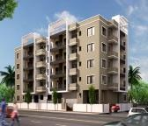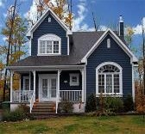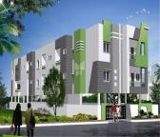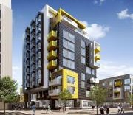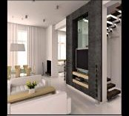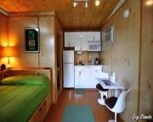

Menu

Search

**Property Images**



Reset Details

Register as :

Email Id :

Password :

Confirm Password :

Female

Male

Gender :

Name :

BirthDate : Contact No : Address :

Registration Form

Cancel

Submit

Select Category

38

38





Log in

Id : Password :

Forget Password?

Sign in

Log in

39

4.4.3 Login page

* 1. **System Navigation**

40



Home Page

Login Page

User Page

Seller Page

Admin LogIn

LogIn

LogIn

LogIn

LogIn

Password

Go to Main

Page

Password not match

Account not exist error

Registration

Search Houses

Add House Details

ViewBuyers

View Houses

View Services

Add Services/Photos/ videos

Add Rate

Booking Options

View Buyers

Manage Bu

Block buyer if necessary

ViewSelle

Contact with Seller

Contact with buyers

ManageSel

Payment Options

Enter Details

Receive Payment Send

Confirmati

on

LogOut

seefeedba

Registration Sucessful

Online/Offline

Get Confirmati

on Feedback

Block

seller

Manage own

New Login Sucessful

LogOut

LogOut

**CHAPTER – 5 –Input Output Design**

41

1. **Home Page**

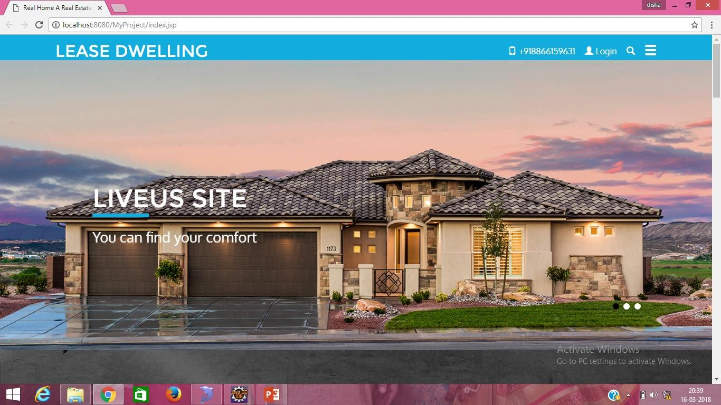

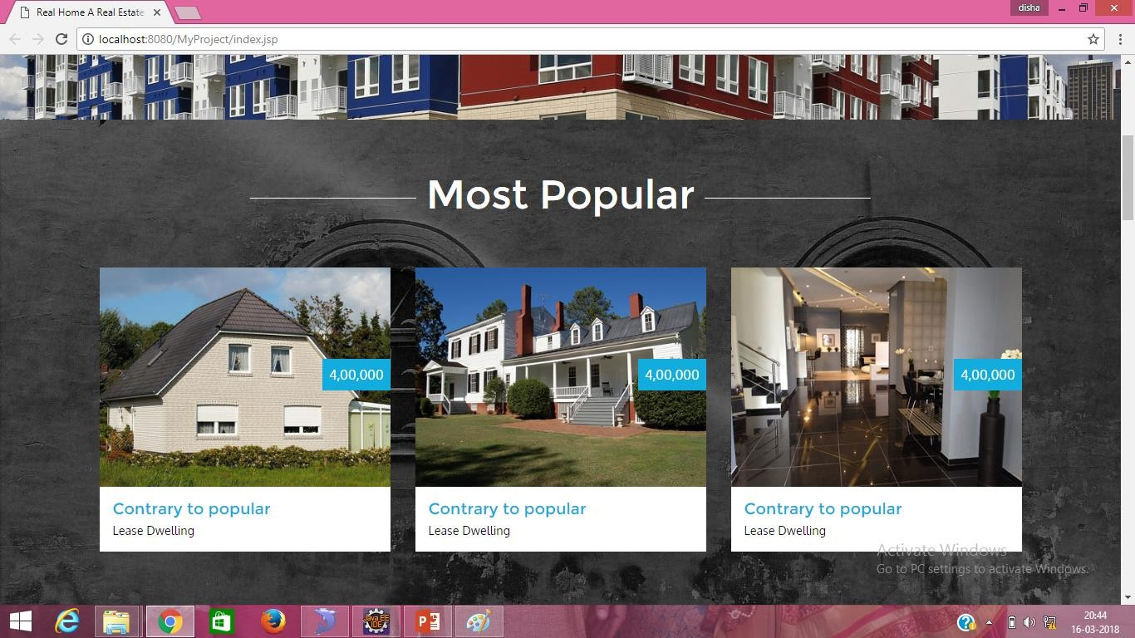

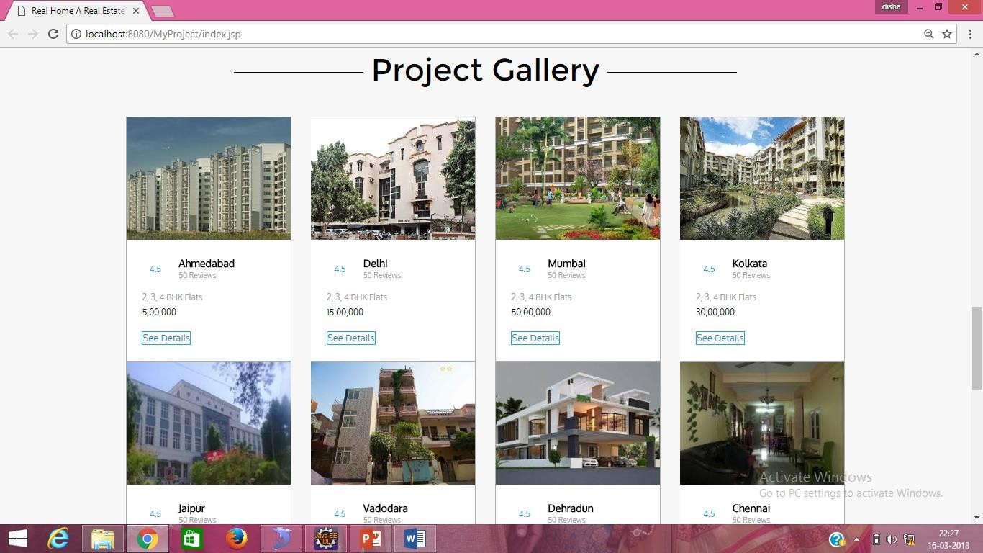

42

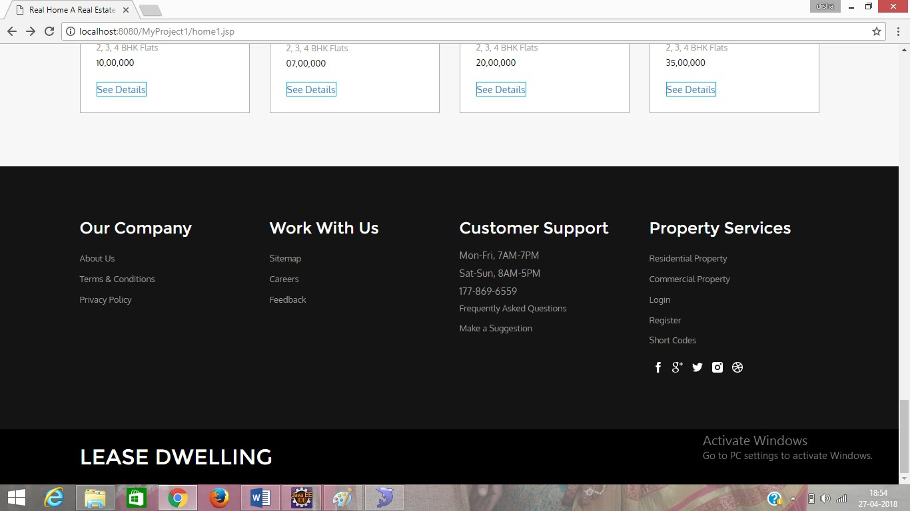

1. **Registration Page**

43

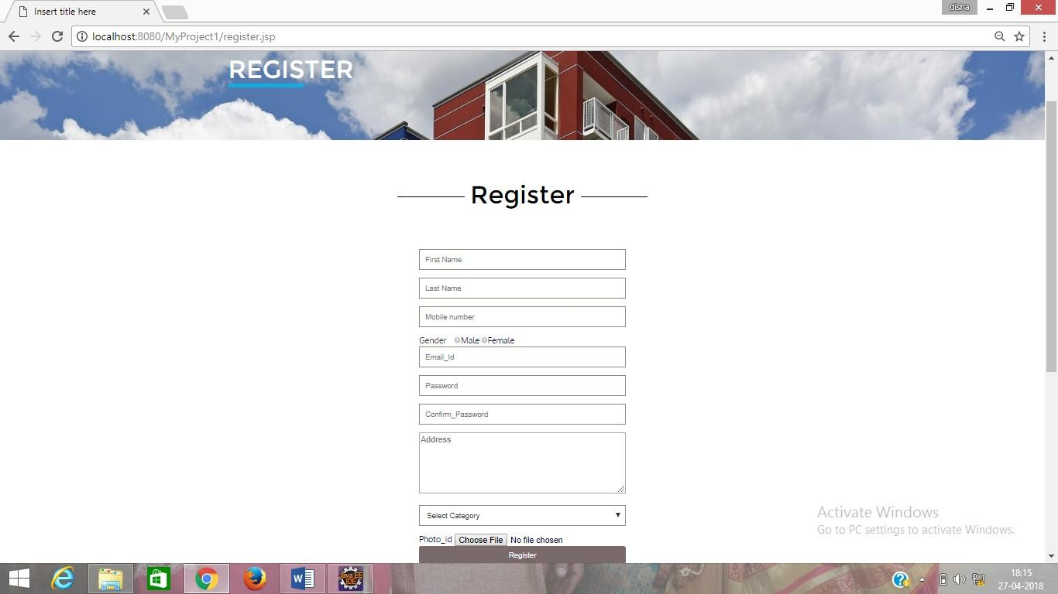

1. **Buyer’s Login**

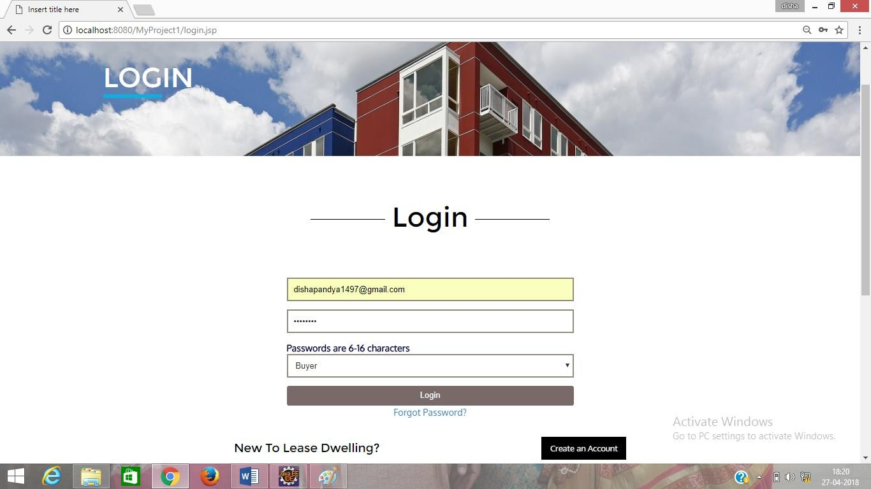

1. **Buyer’s Home Page**

44

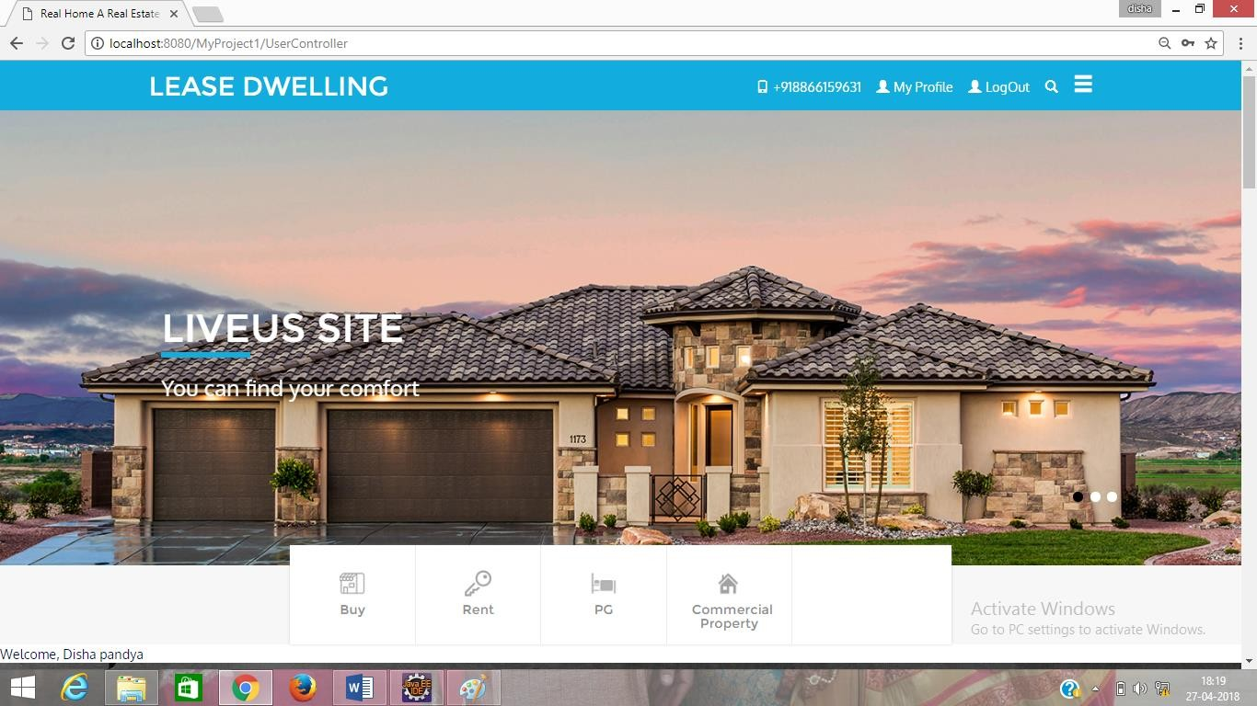

1. **Buy Property**

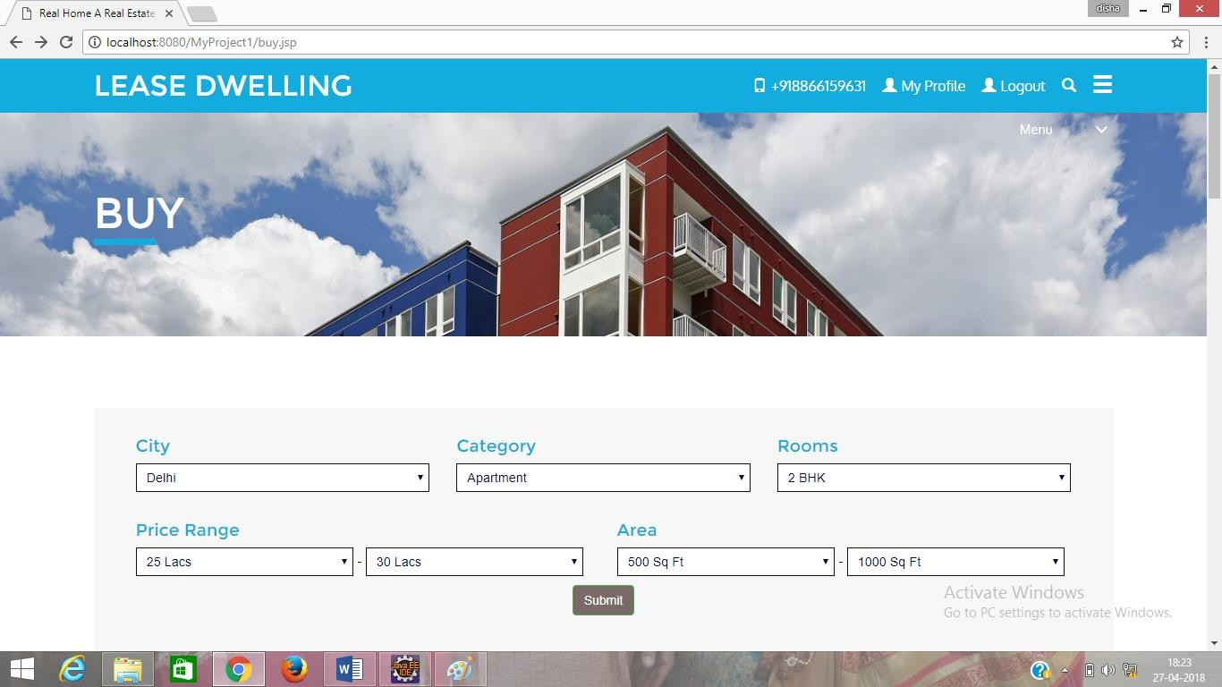

1. **Select Property as Your Choice**

45

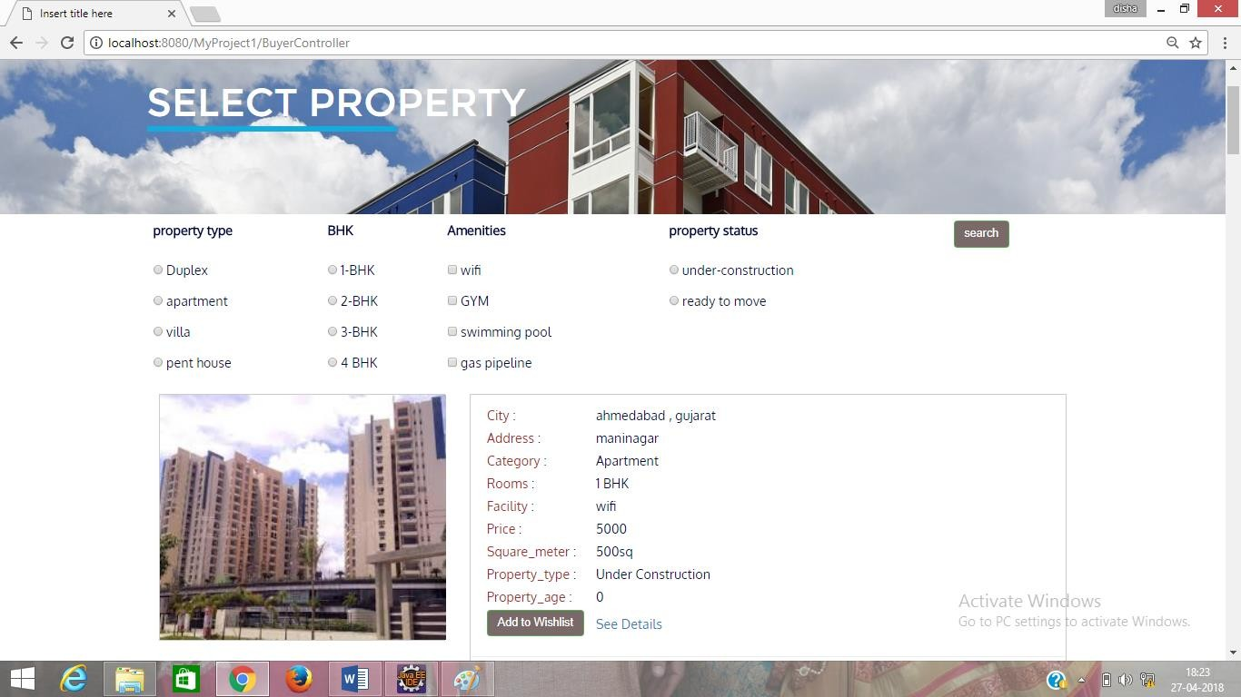

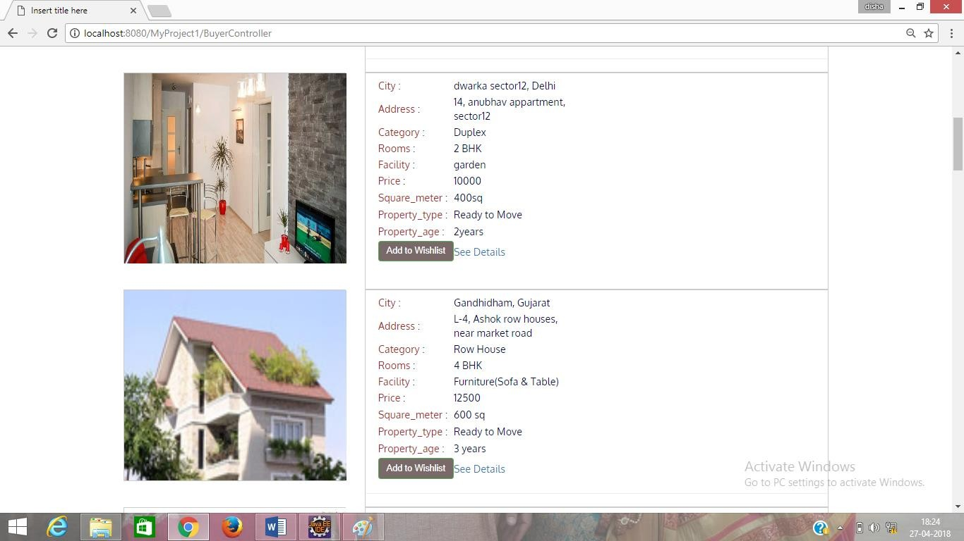

46

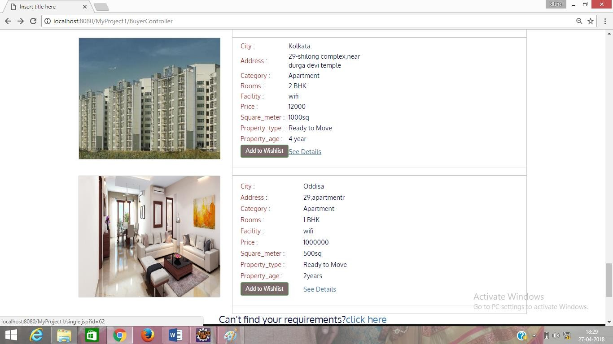

1. **See Details of Property**

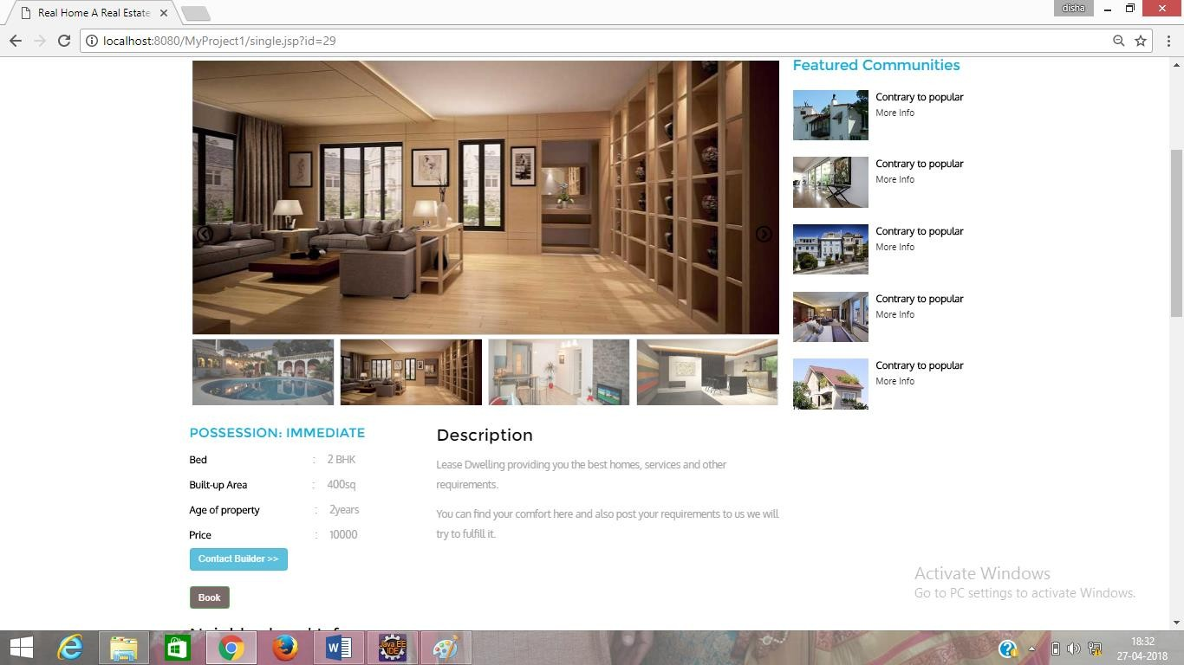

47

1. **You can Contact Seller Here otherwise Book Online**

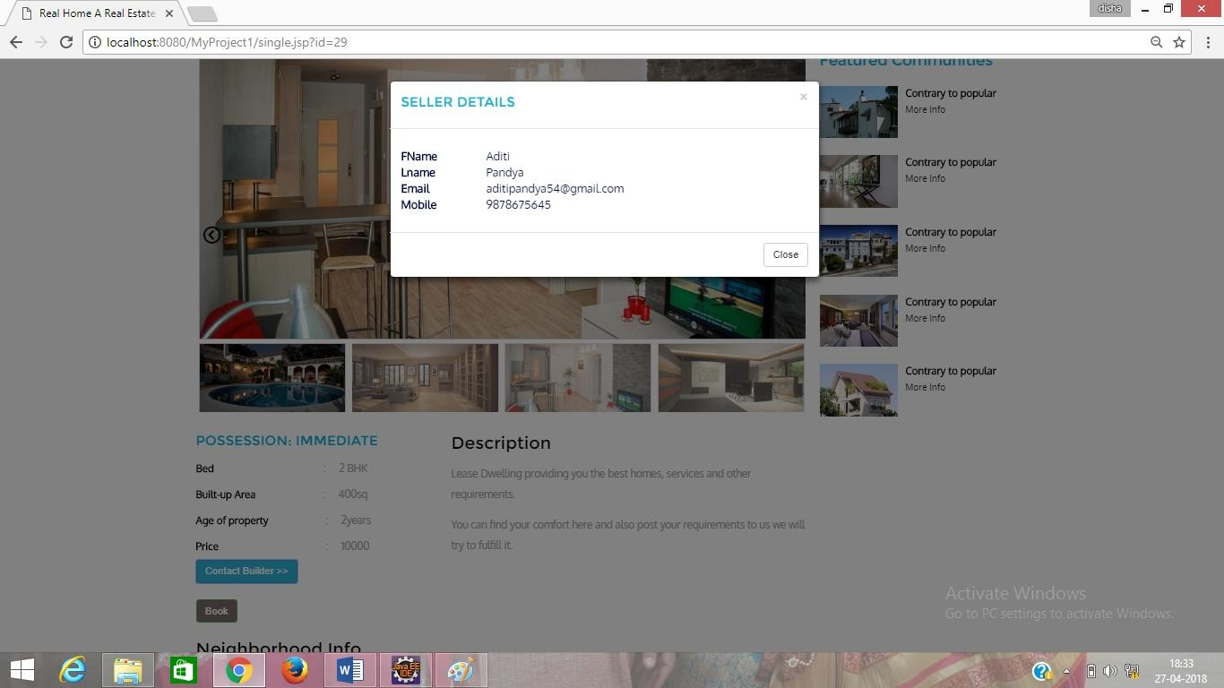

1. **If you book online with token than select Checkout**

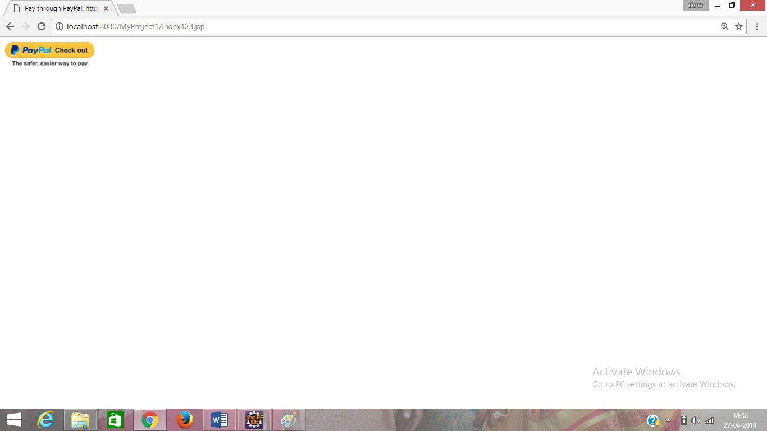

1. **After Checkout Login to Paypal Account**

48

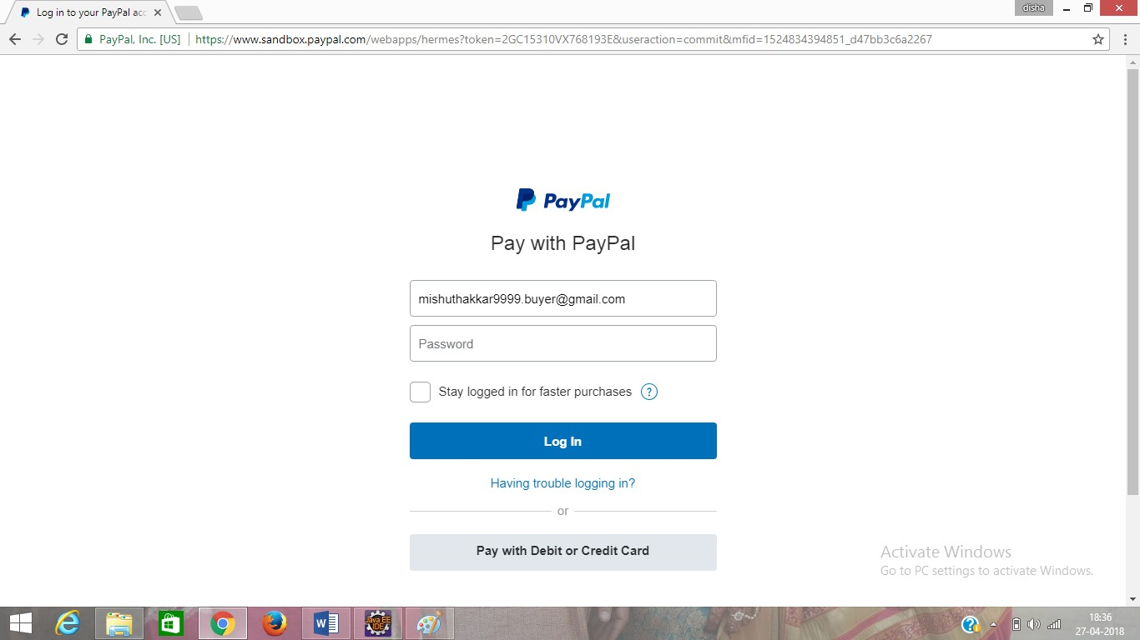

1. **Here you found your total Payble amount**

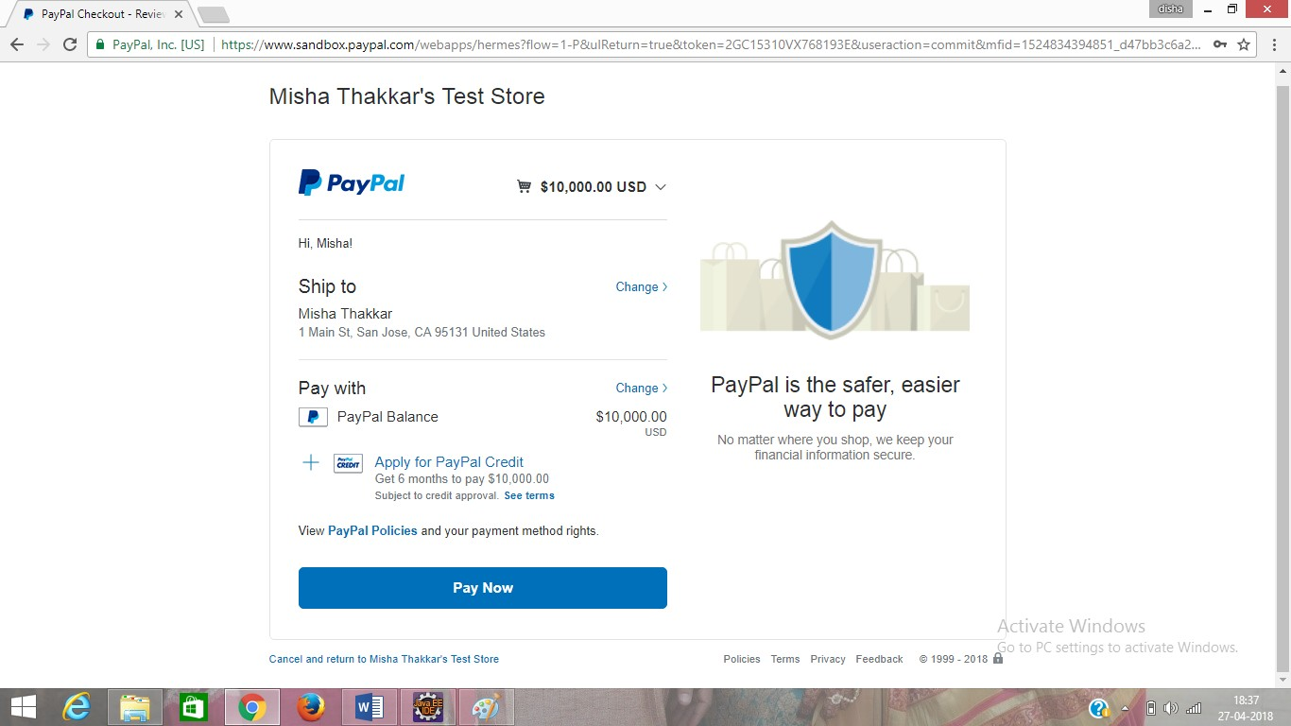

49

1. **Select Paynow Button and you can see your transaction**

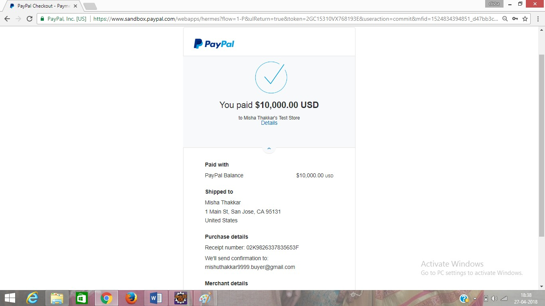

1. **If you not found property as per your choice then fill this form and you will get notification when property will available**

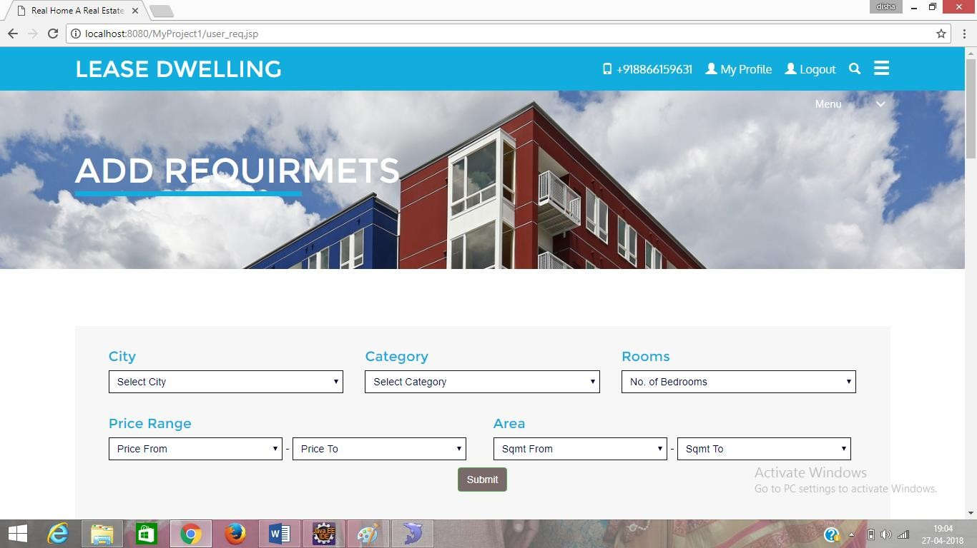

50

1. **Here Also You can Take Property On Rent & PG**

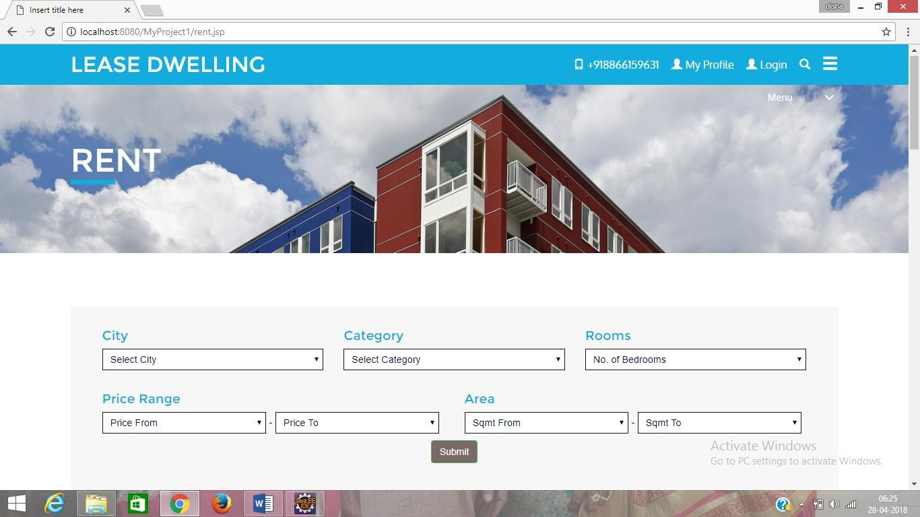

1. **You Can Find Property on rent & Pg here as per your choice**

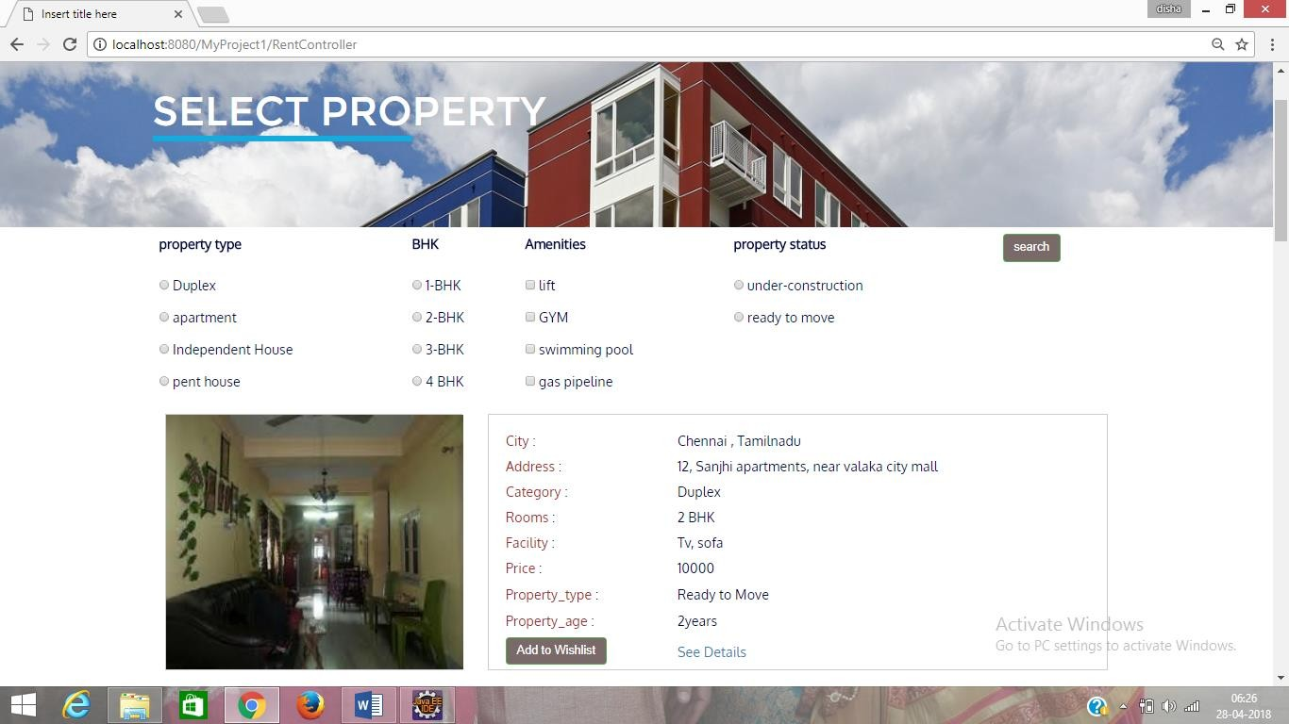

**Next Procedure is same as above for rent & Pg**

51

1. **If you want commercial property then select this link**

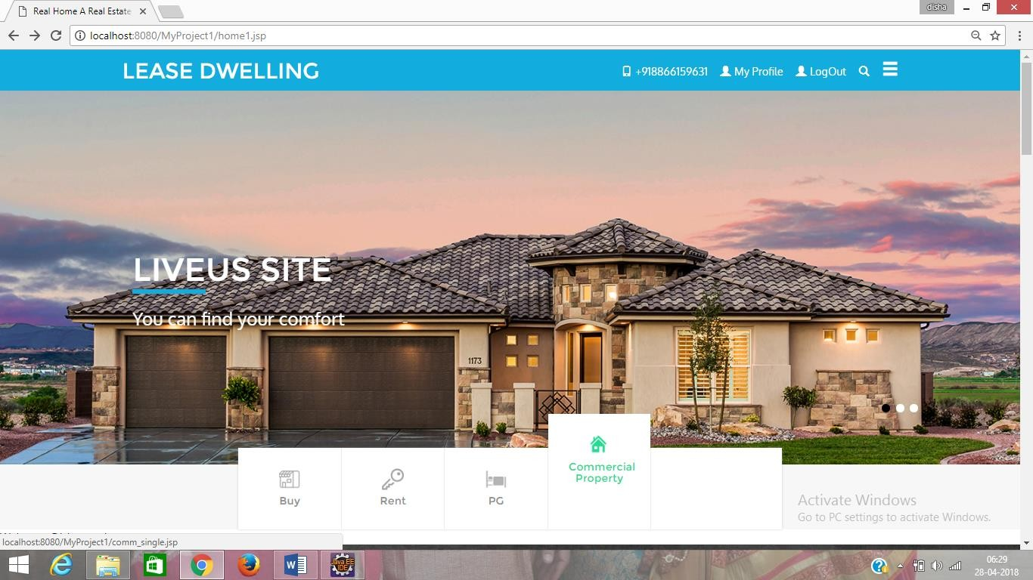

1. **Here you can find commercial property as per choice**

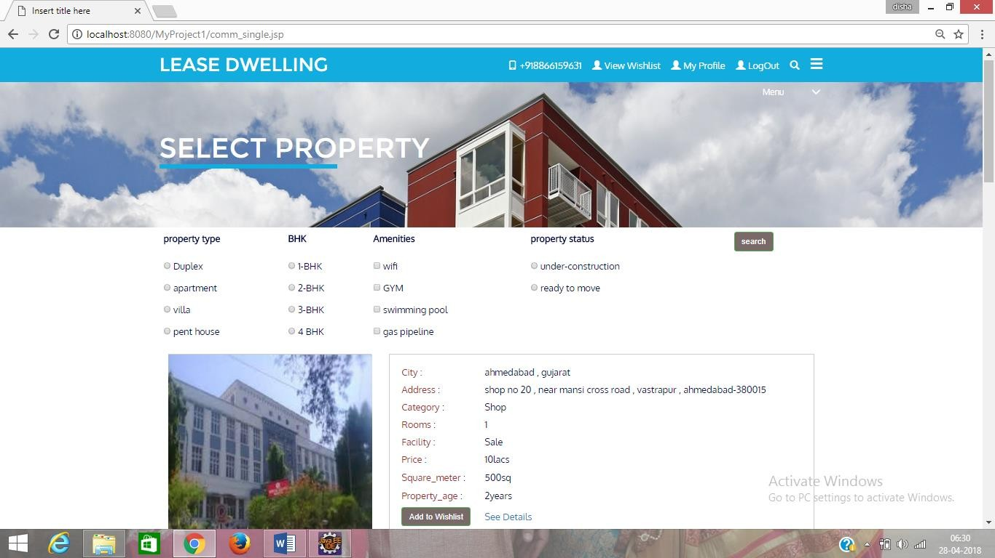

52

1. **See Commercial Property Details and Book**

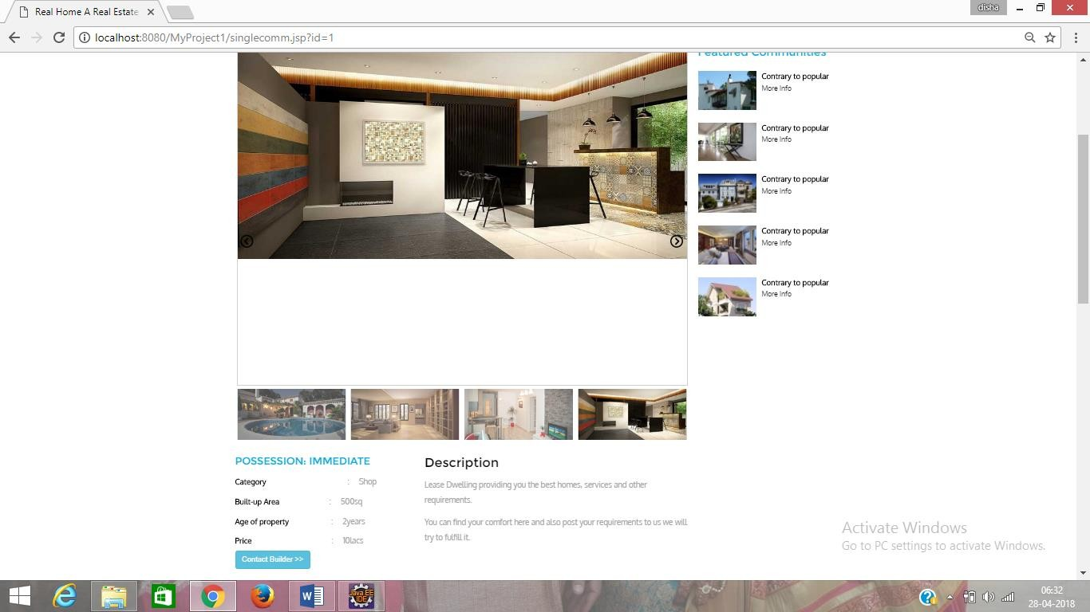

1. **Seller’s Login**

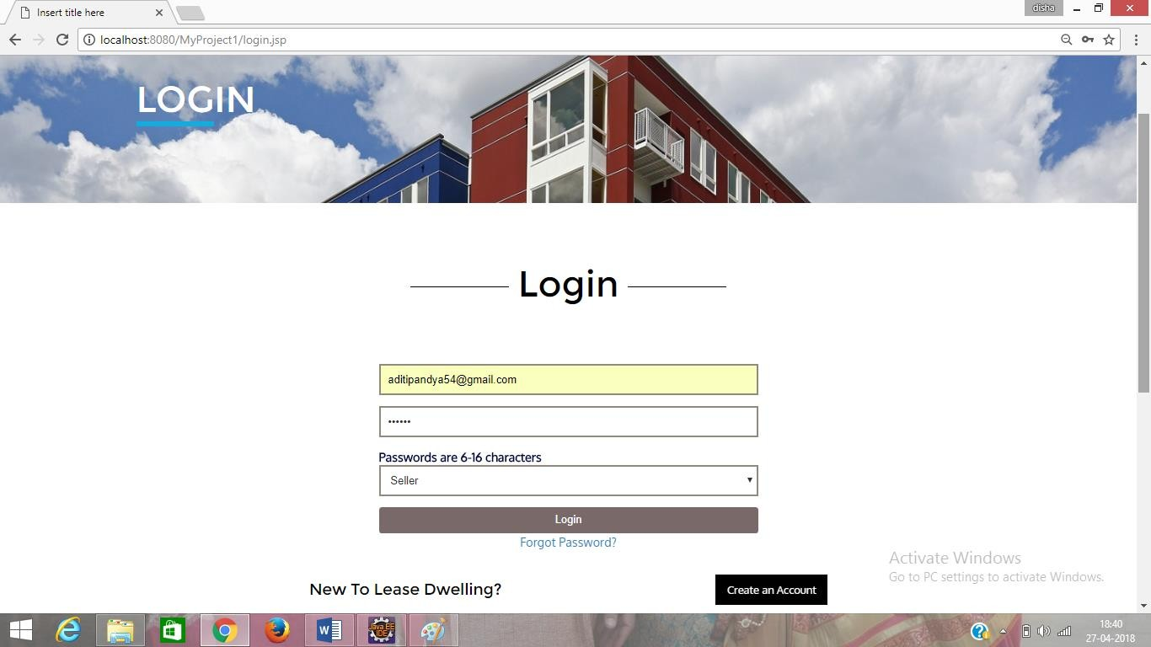

1. **Seller’s Home Page**

53

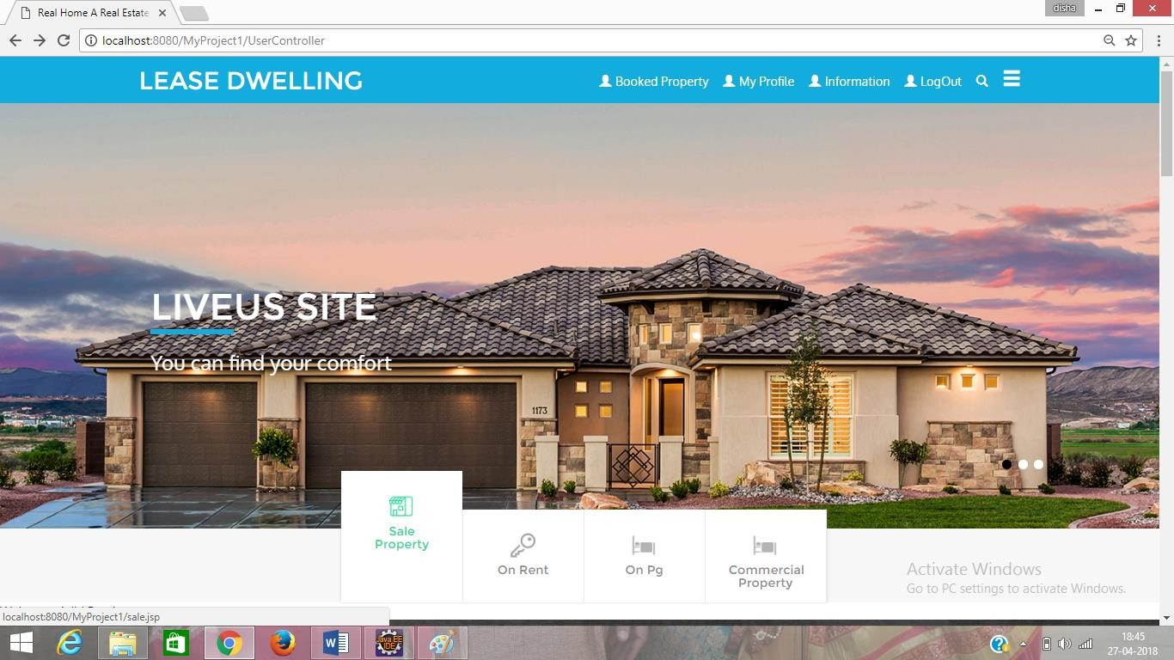

1. **Seller can Post their property on here**

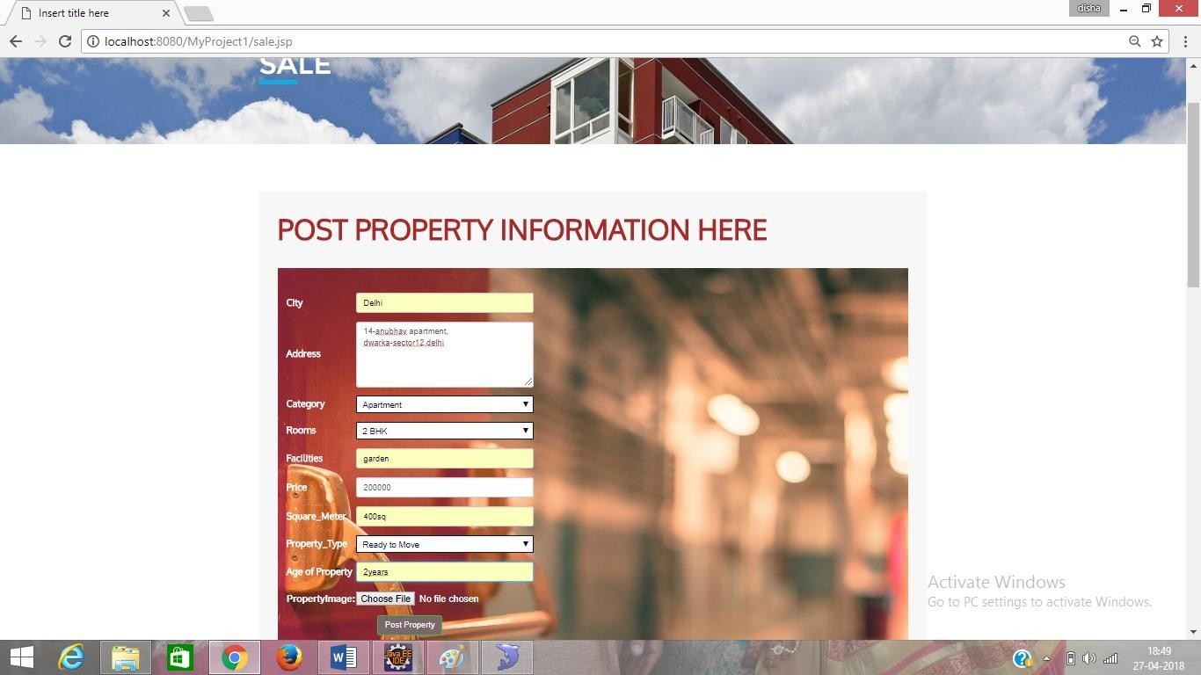

1. **Seller can See them Post property on information link and also can update or delete property**

54

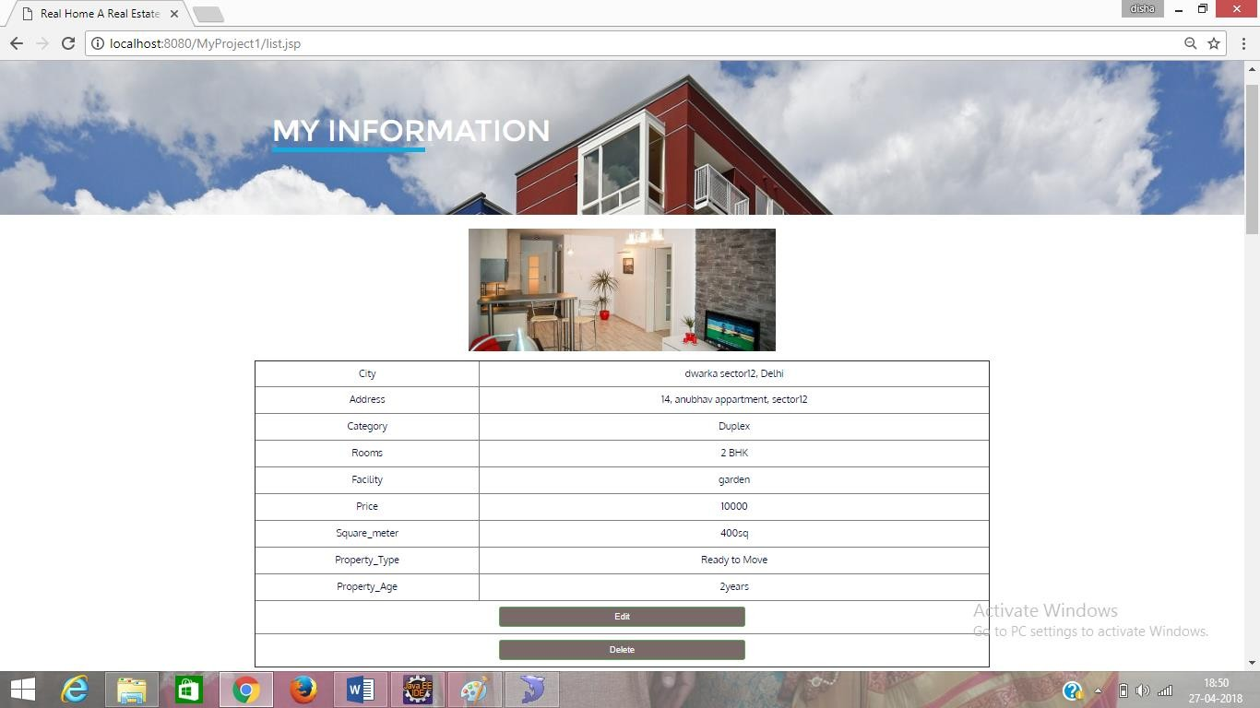

1. **If Some Buyer Buy property than Seller see information on Booked Property link**

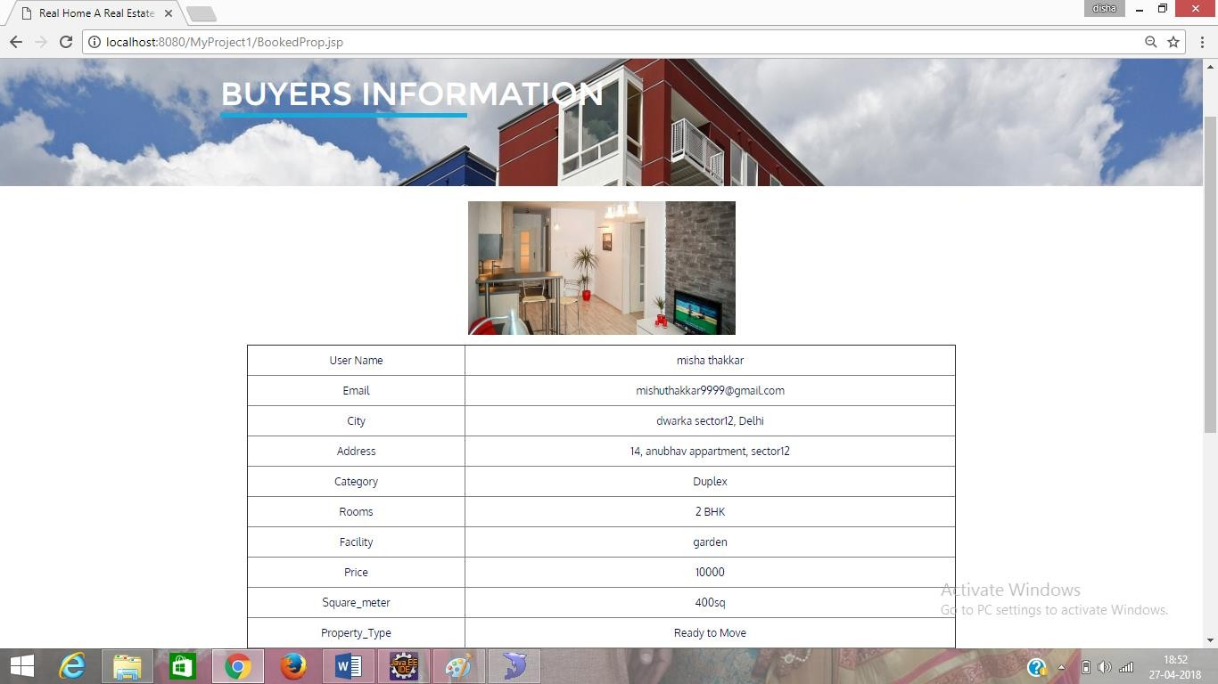

55

1. **User Can Manage their profile here**

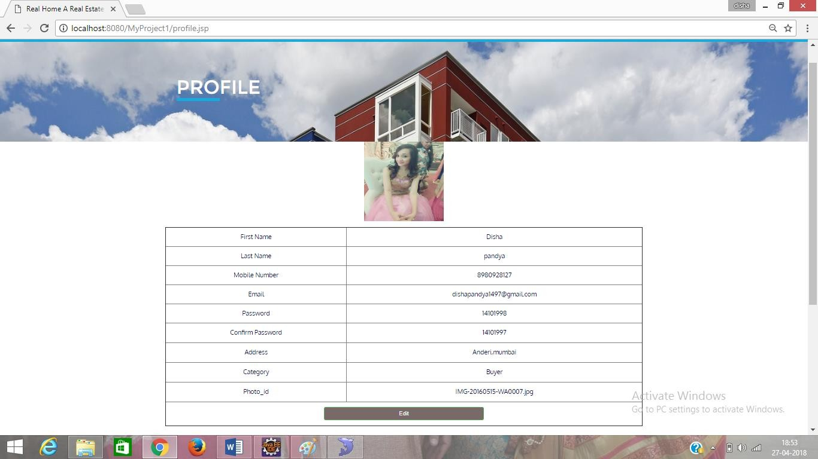

1. **By Clicking Edit Button user can edit their profile**

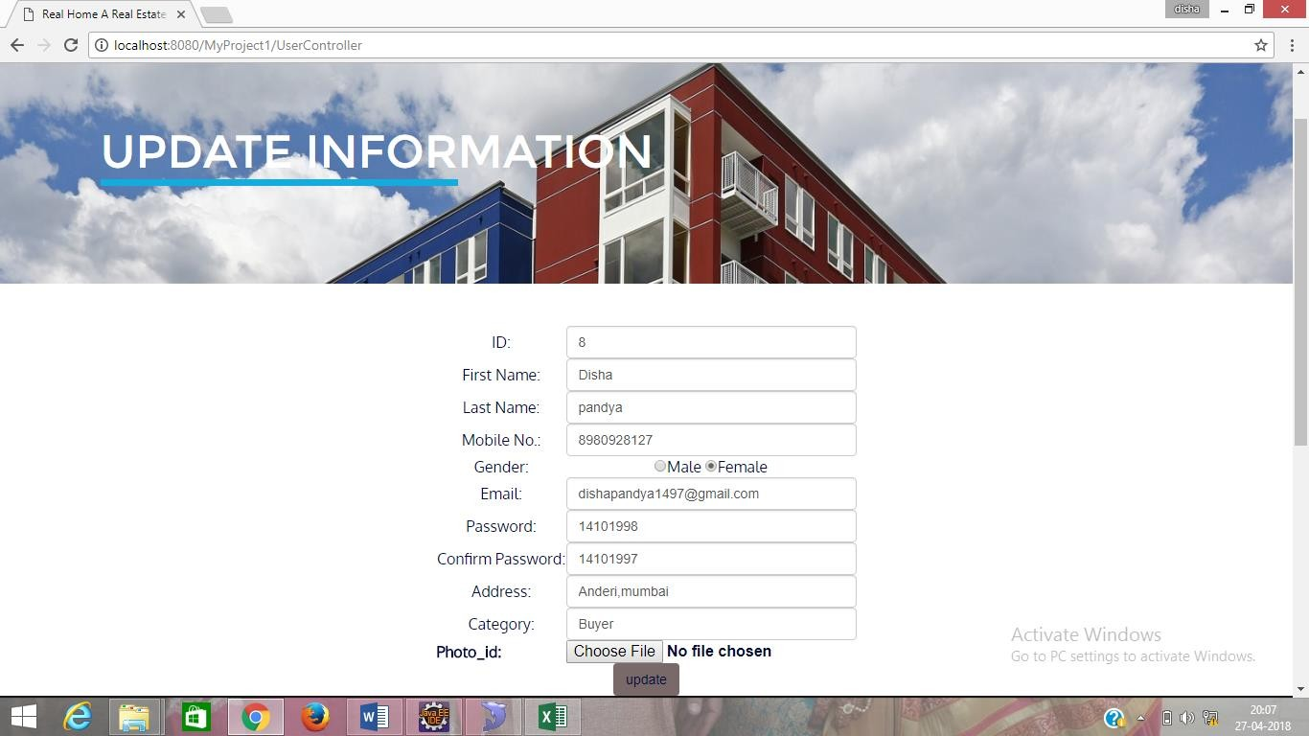

1. **Feedback Page**

56

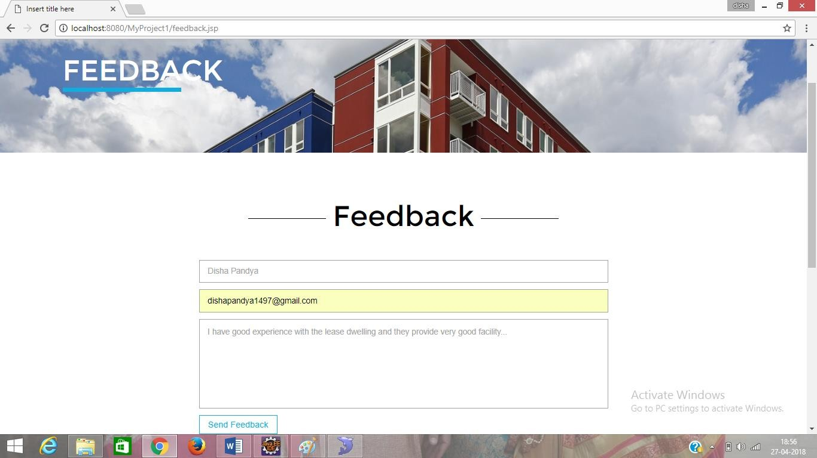

1. **Contact Us Page**

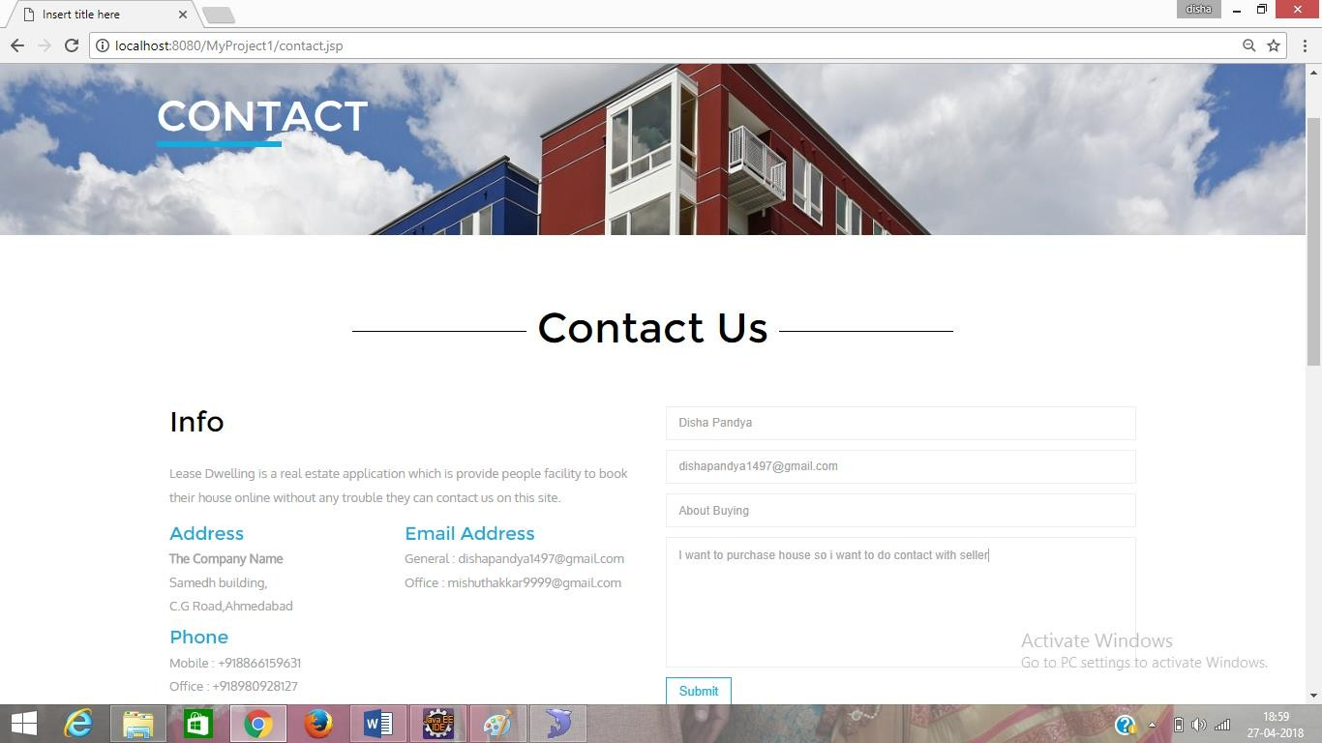

1. **About Us Page**

57

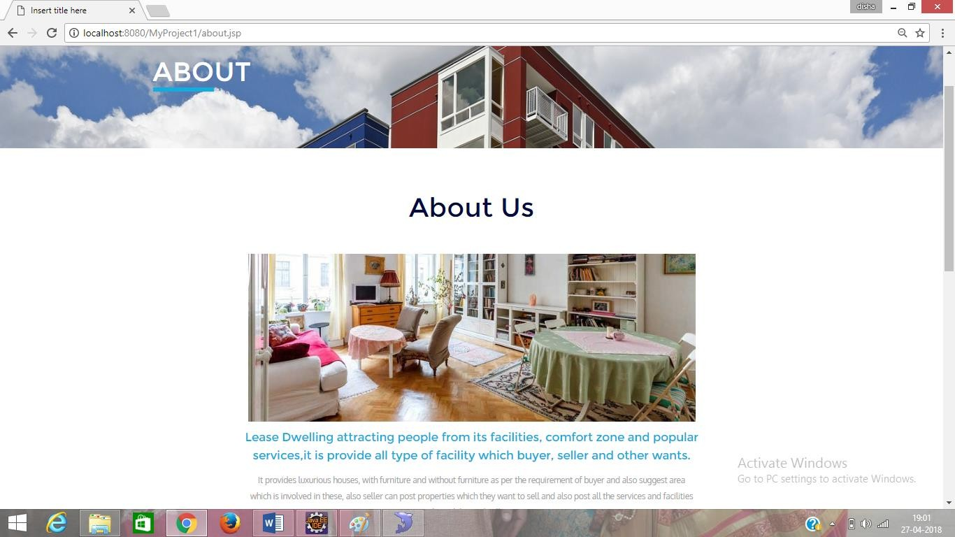

* 1. **Admin Signin**

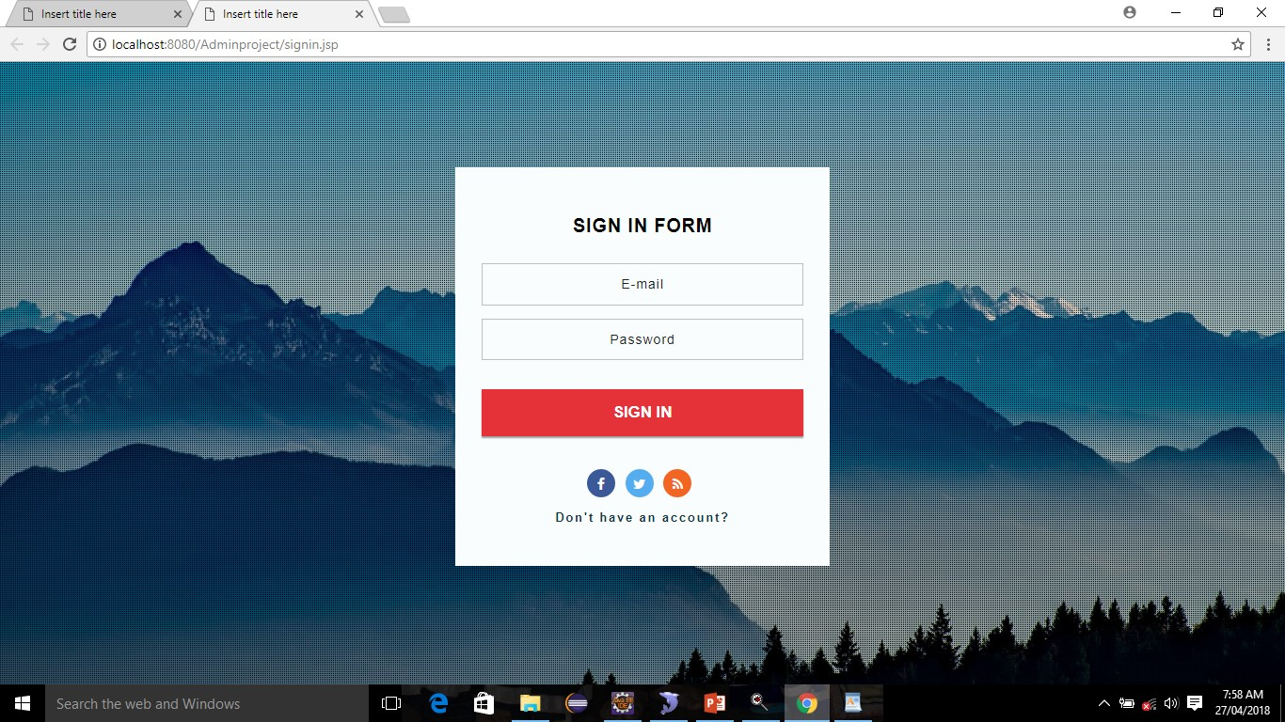

* 1. **User Table**

58

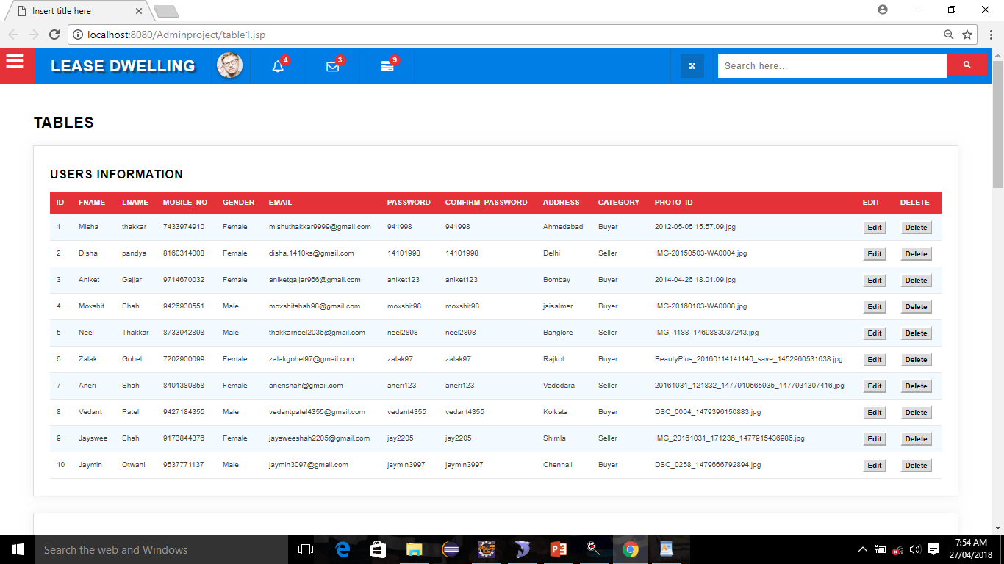

* 1. **Search Property Table**

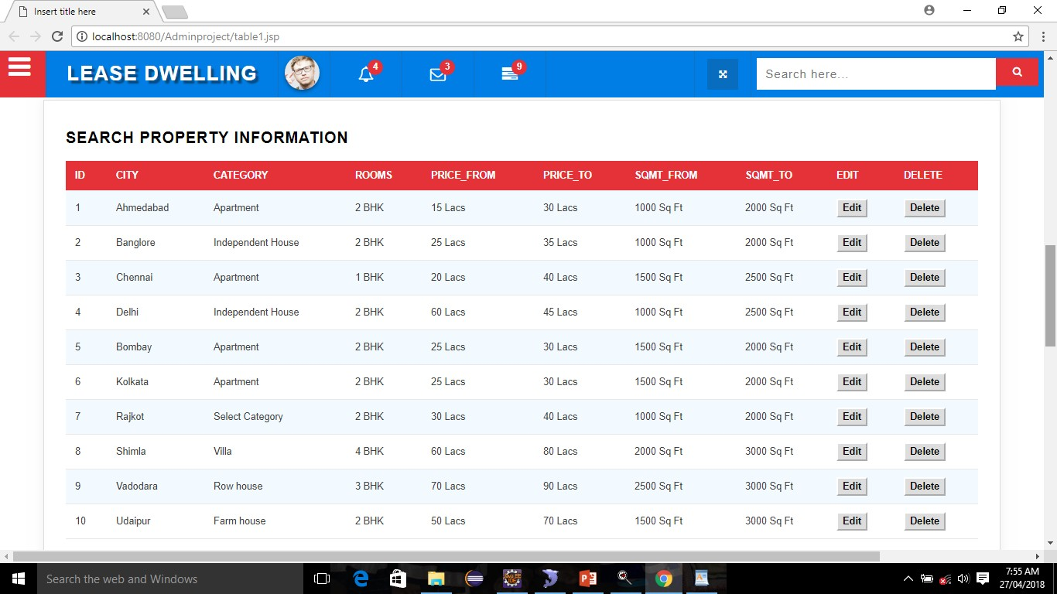

* 1. **Buyer Requirement Table**

59

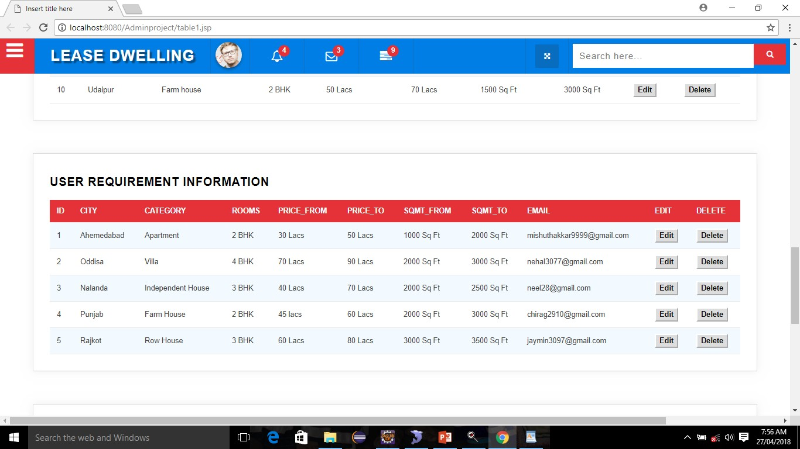

* 1. **Post Property Table**

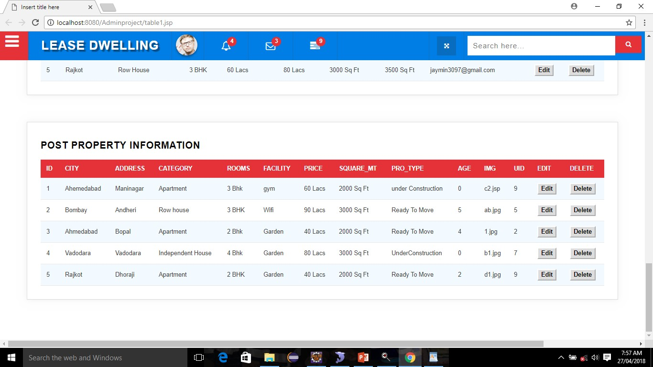

* 1. **Feedback Table**

60

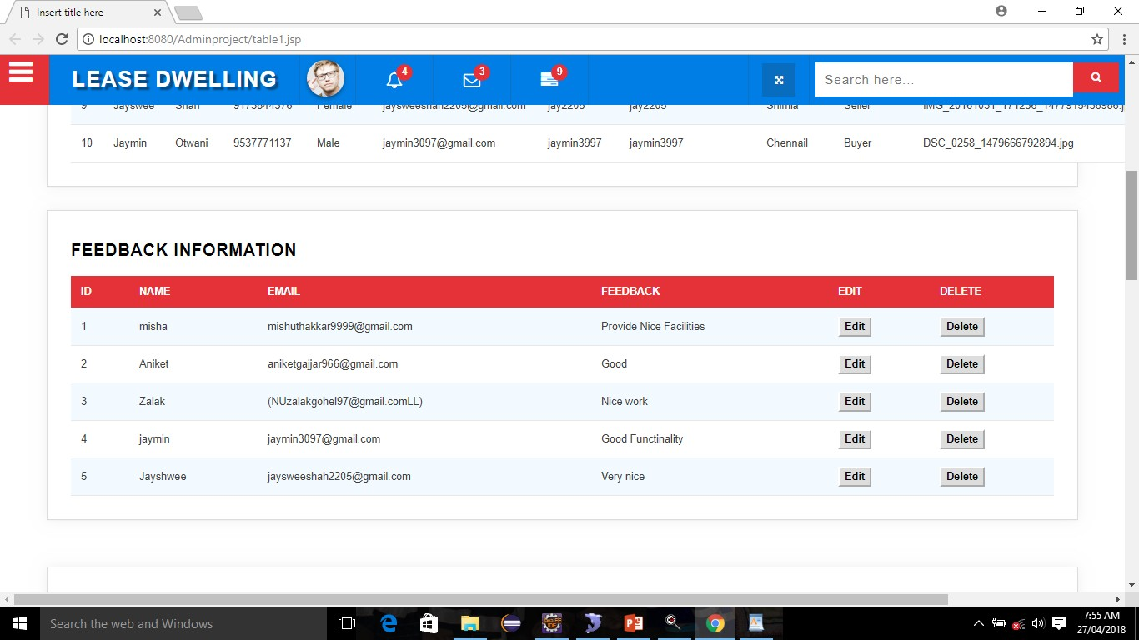

**Chapter 6 System Testing**

61

|  |  |  |  |  |
| --- | --- | --- | --- | --- |
| **Sr No** | **Page Name** | **Input** | **Valid** | **Invalid** |
| **1** | **User Registration** | **First Name Last Name Mobile No Gender Email_Id Password**  **Confirm_Password Address**  **Category Photo_id** | **Disha Pandya 8989756545**  **Female** [**dishapandya1497@gmail.com**](mailto:dishapandya1497@gmail.com) **1410@1997**  **1410@1997**  **L-4,kenyug,Near Satellite Buyer/Seller**  **Fill up** | **Disha123 123pandya 8989adsd NoSelection Disha.com 1410@1997**  **14101998**  **NoSelection NoSelection NotAdd** |

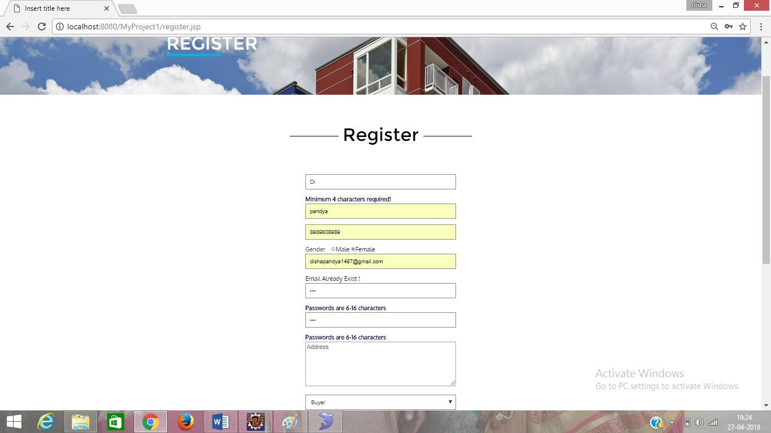

62

|  |  |  |  |  |
| --- | --- | --- | --- | --- |
| **Sr No** | **Page Name** | **Input** | **Valid** | **Invalid** |
| **2** | **User Login** | **Email_id Password Category** | [**dishapandya1497@gmail.com**](mailto:dishapandya1497@gmail.com) **1410@1997**  **Buyer/Seller** | **Disha.com 14101998**  **NotSelected** |

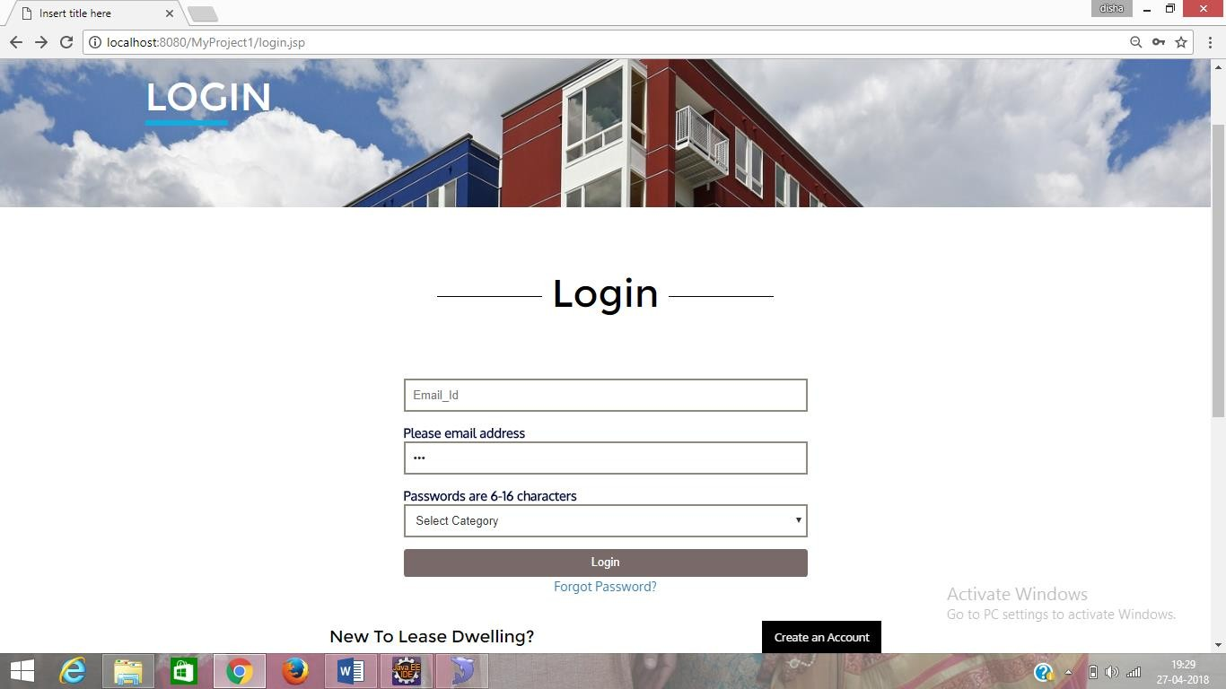

|  |  |  |  |  |
| --- | --- | --- | --- | --- |
| **Sr No** | **Page Name** | **Input** | **Valid** | **Invalid** |
| **3** | **Forgot Password** | **Email_id OTP**  **New Password Confirm Password** | [**dishapandya1497@gmail.com**](mailto:dishapandya1497@gmail.com) **546235**  **disha@123 disha@123** | **Disha.com Aa1122**  **disha123 disha14** |

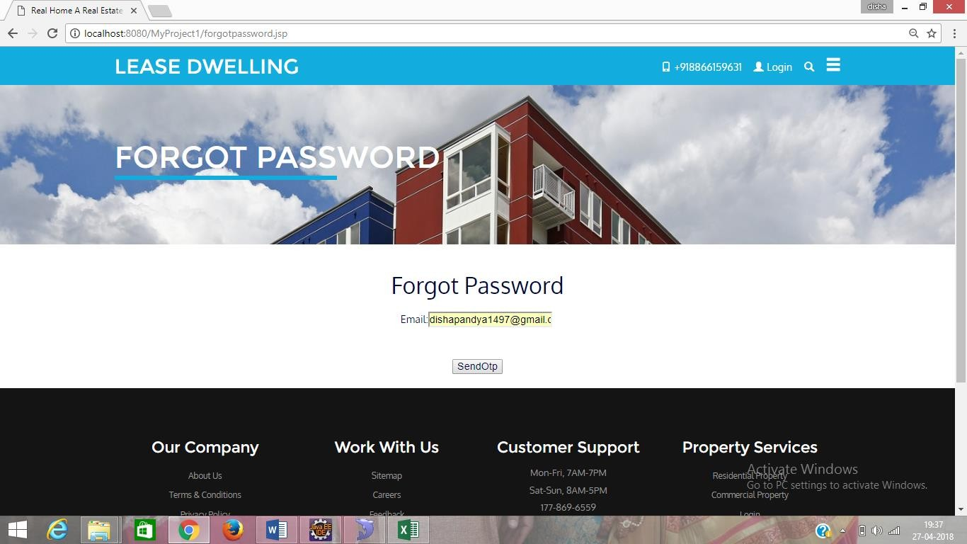

63

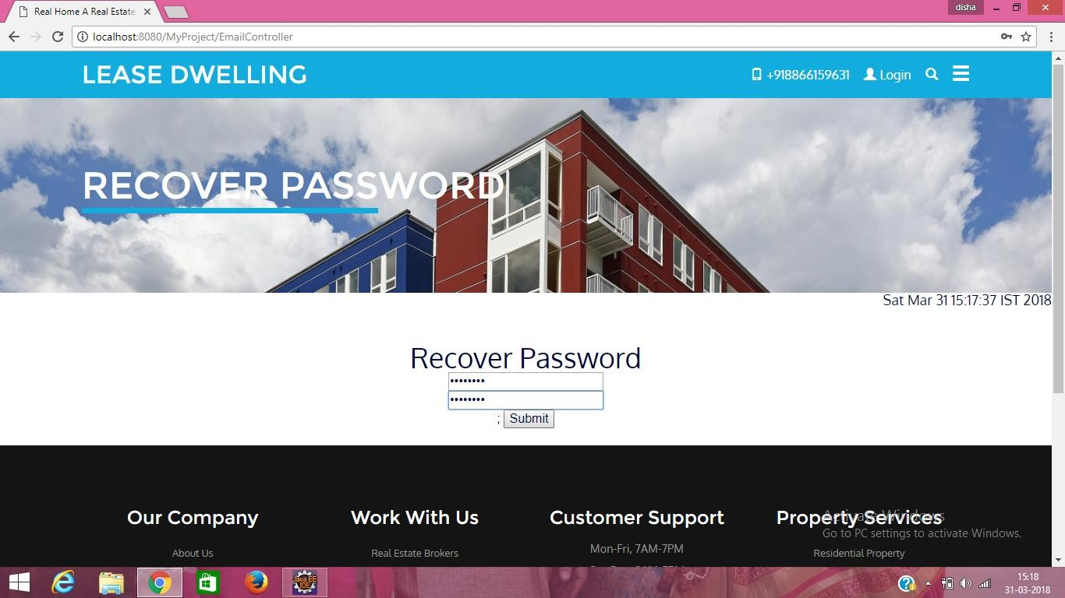

64

|  |  |  |  |  |
| --- | --- | --- | --- | --- |
| **Sr No** | **Page Name** | **Input** | **Valid** | **Invalid** |
| **4** | **Post Property** | **City Address Category Rooms Facilities Price**  **Square_Meter Property_Type Age of Property Property_Image** | **Ahmedabad**  **L-4,kenyug, near Satellite Apartment**  **2 BHK Wi-Fi 100000 500sq**  **Ready to Move 4Year**  **Fill Up** | **NotEntered NotEntered NotSelect NotSelect NotEntered NotEntered NotEntered NotSelect NotEntered**  **Not Fill Up** |

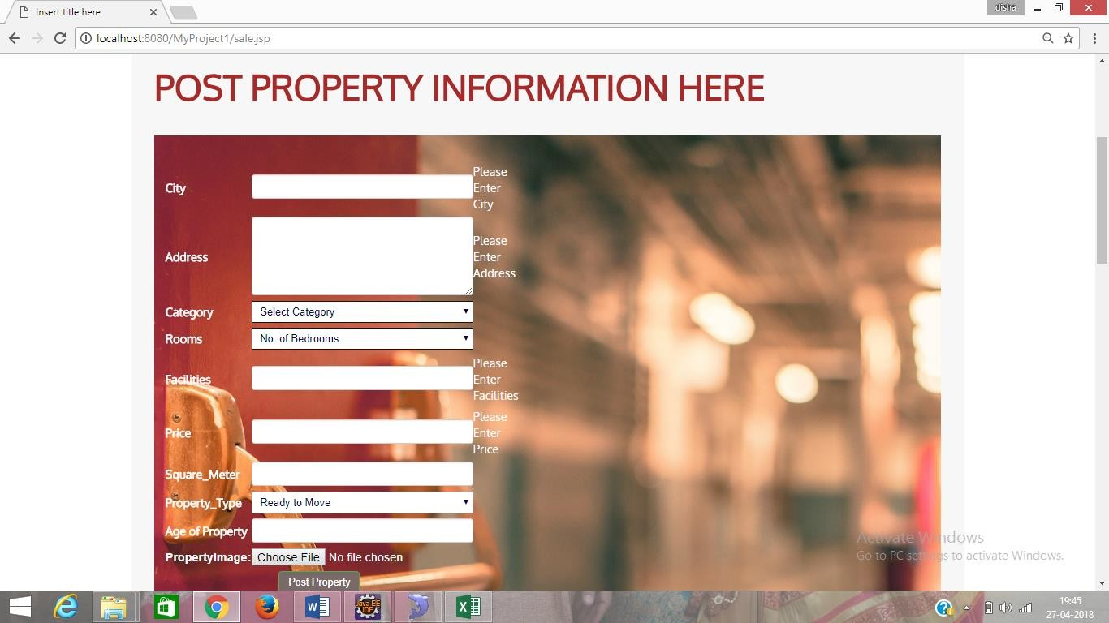

65

|  |  |  |  |  |
| --- | --- | --- | --- | --- |
| **Sr No** | **Page Name** | **Input** | **Valid** | **Invalid** |
| **5** | **Buy Property** | **City Category Rooms Price Range Area** | **Ahmedabad Apartment 3BHK**  **100000 to 200000**  **500sq to 1000sq** | **NotSelected NotSelected NotSelected NotSelected NotSelected** |

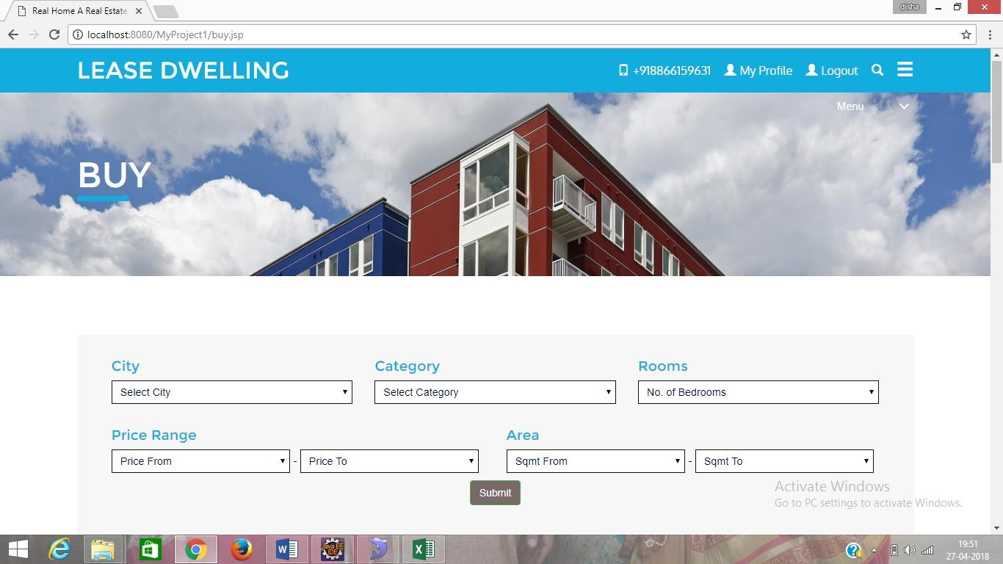

|  |  |  |  |  |
| --- | --- | --- | --- | --- |
| **Sr No** | **Page Name** | **Input** | **Valid** | **Invalid** |
| **6** | **Admin Signin** | **Login Password** | [**mishuthakkar9999@gmail.com**](mailto:mishuthakkar9999@gmail.com) **94@1998** | **Mishu.com 941992** |



66

**CHAPTER-7- SUMMARY**

67

* 1. **Assumption:**
     + User can register themselves and then they can make their login id and password.
     + Users can search houses for purchase or for rent as per their requirements.
     + If users and clients didn't get house according to their requirements and conditions , they can ask for their as a special case and feedback too.
     + Clients and Landlords both the users can make their transaction through suitable payment methods either online methods like net-banking and so on , or any offline method like cash.
     + Clients can easily cancel their bookings and get deposit back without passing through any lenghty process.
     + Landlord can register themselves and then they can make their login id and password.
     + Landlords can indicate information and services regarding their properties with the help of this web application.
     + Landlord can see the requirements of clients and give them surety that they will complete their requirements.
     + Landlord can easily connect with clients through our web application.
     + Administrator can manage both user, client and landlord account.
  2. **Limitations:**
* Main drawback of this application is that , it demands for high speed data to work on it.
* It does not provide services in offline mode.
* Also to watch videos and images it consumes some more data usage of high speed.
  1. **Future Scope:**
     + In future our main efforts will be for making this application more user friendly by adding more and advance funtionalities.
     + We will provide better security to data and other sensitive contents of users.
     + Whenever users want any help related out web application they will get more satisfied and quick resposes.

68

**Bibliography**

**->** Software Engineering a Practitioner's Approach 7th Edition

By Roger Pressman

* 99acres.com

([https://www.99acres.com](https://www.99acres.com/))

* Magicbricks.com

(https://www.magicbricks.com)